

Indywidualny identyfikator uczestnika konkursu

WOJEWÓDZKI KONKURS PRZEDMIOTOWY   
Z FIZYKI

organizowany przez Łódzkiego Kuratora Oświaty   
dla uczniów szkół podstawowych w roku szkolnym 2024/2025

TEST – ETAP REJONOWY

* Na wypełnienie testu masz 90 **min**.
* Arkusz liczy **16 stron** i zawiera **21 zadań,** w tym brudnopis.
* Przed rozpoczęciem pracy sprawdź, czy Twój arkusz jest kompletny. Jeżeli zauważysz usterki, zgłoś je Komisji Konkursowej.
* Zadania czytaj uważnie i ze zrozumieniem.
* Odpowiedzi wpisuj długopisem bądź piórem, kolorem czarnym lub niebieskim.
* Dbaj o czytelność pisma i precyzję odpowiedzi.
* W zadaniach zamkniętych zaznacz prawidłową odpowiedź, wstawiając znak X we właściwym miejscu.
* Jeżeli się pomylisz, błędne zaznaczenie otocz kółkiem i zaznacz znakiem X inną odpowiedź.
* Oceniane będą tylko te odpowiedzi, które umieścisz w miejscu do tego przeznaczonym.
* Do każdego numeru zadania podana jest maksymalna liczba punktów możliwa do uzyskania za prawidłową odpowiedź.
* Pracuj samodzielnie. Postaraj się udzielić odpowiedzi na wszystkie pytania.
* Nie używaj korektora. Jeśli pomylisz się w zadaniach otwartych, przekreśl błędną odpowiedź   
  i wpisz poprawną.
* Korzystaj tylko z przyborów i materiałów określonych w regulaminie konkursu.
* W zadaniach przyjmij wartość przyspieszenia ziemskiego 10 $\frac{m}{s^{2}}$.

***Powodzenia***

Maksymalna liczba punktów - 80

Liczba uzyskanych punktów - …..

Imię i nazwisko ucznia: …………………………………………..……………

wypełnia Komisja Konkursowa po zakończeniu sprawdzenia prac

Podpisy członków komisji sprawdzających prace:

1. ………………………………………………….. ……………….……………

(imię i nazwisko) (podpis)

1. ………………………………………………….. ……………….……………

(imię i nazwisko) (podpis)

# Zadanie nr 1 (0-9 pkt.)

Poniższy wykres prezentuje szybkość poruszania się Zająca w czasie.

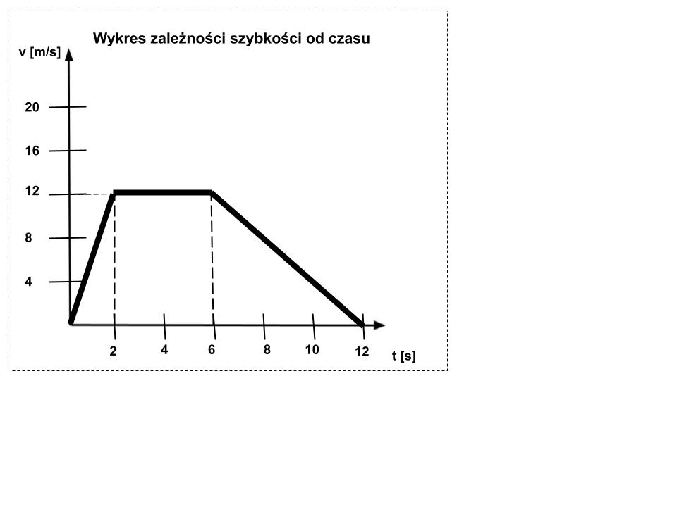

1. Napisz, jakim ruchem poruszał się Zając od 6 s do 12 s.

|  |  |  |  |  |  |  |  |  |  |  |  |  |  |  |  |  |  |  |  |  |  |  |  |  |  |  |
| --- | --- | --- | --- | --- | --- | --- | --- | --- | --- | --- | --- | --- | --- | --- | --- | --- | --- | --- | --- | --- | --- | --- | --- | --- | --- | --- |
|  |  |  |  |  |  |  |  |  |  |  |  |  |  |  |  |  |  |  |  |  |  |  |  |  |  |  |
|  |  |  |  |  |  |  |  |  |  |  |  |  |  |  |  |  |  |  |  |  |  |  |  |  |  |  |
|  |  |  |  |  |  |  |  |  |  |  |  |  |  |  |  |  |  |  |  |  |  |  |  |  |  |  |

1. Napisz, jaką szybkość miał Zając po dziewięciu sekundach ruchu.

|  |  |  |  |  |  |  |  |  |  |  |  |  |  |  |  |  |  |  |  |  |  |  |  |  |  |  |
| --- | --- | --- | --- | --- | --- | --- | --- | --- | --- | --- | --- | --- | --- | --- | --- | --- | --- | --- | --- | --- | --- | --- | --- | --- | --- | --- |
|  |  |  |  |  |  |  |  |  |  |  |  |  |  |  |  |  |  |  |  |  |  |  |  |  |  |  |
|  |  |  |  |  |  |  |  |  |  |  |  |  |  |  |  |  |  |  |  |  |  |  |  |  |  |  |
|  |  |  |  |  |  |  |  |  |  |  |  |  |  |  |  |  |  |  |  |  |  |  |  |  |  |  |

1. Oblicz drogę przebytą po pierwszych dwóch sekundach ruchu.

|  |  |  |  |  |  |  |  |  |  |  |  |  |  |  |  |  |  |  |  |  |  |  |  |  |  |  |
| --- | --- | --- | --- | --- | --- | --- | --- | --- | --- | --- | --- | --- | --- | --- | --- | --- | --- | --- | --- | --- | --- | --- | --- | --- | --- | --- |
|  |  |  |  |  |  |  |  |  |  |  |  |  |  |  |  |  |  |  |  |  |  |  |  |  |  |  |
|  |  |  |  |  |  |  |  |  |  |  |  |  |  |  |  |  |  |  |  |  |  |  |  |  |  |  |
|  |  |  |  |  |  |  |  |  |  |  |  |  |  |  |  |  |  |  |  |  |  |  |  |  |  |  |
|  |  |  |  |  |  |  |  |  |  |  |  |  |  |  |  |  |  |  |  |  |  |  |  |  |  |  |
|  |  |  |  |  |  |  |  |  |  |  |  |  |  |  |  |  |  |  |  |  |  |  |  |  |  |  |
|  |  |  |  |  |  |  |  |  |  |  |  |  |  |  |  |  |  |  |  |  |  |  |  |  |  |  |

1. Oblicz szybkość średnią Zająca dla pierwszych sześciu sekund ruchu

|  |  |  |  |  |  |  |  |  |  |  |  |  |  |  |  |  |  |  |  |  |  |  |  |  |  |  |
| --- | --- | --- | --- | --- | --- | --- | --- | --- | --- | --- | --- | --- | --- | --- | --- | --- | --- | --- | --- | --- | --- | --- | --- | --- | --- | --- |
|  |  |  |  |  |  |  |  |  |  |  |  |  |  |  |  |  |  |  |  |  |  |  |  |  |  |  |
|  |  |  |  |  |  |  |  |  |  |  |  |  |  |  |  |  |  |  |  |  |  |  |  |  |  |  |
|  |  |  |  |  |  |  |  |  |  |  |  |  |  |  |  |  |  |  |  |  |  |  |  |  |  |  |
|  |  |  |  |  |  |  |  |  |  |  |  |  |  |  |  |  |  |  |  |  |  |  |  |  |  |  |
|  |  |  |  |  |  |  |  |  |  |  |  |  |  |  |  |  |  |  |  |  |  |  |  |  |  |  |
|  |  |  |  |  |  |  |  |  |  |  |  |  |  |  |  |  |  |  |  |  |  |  |  |  |  |  |
|  |  |  |  |  |  |  |  |  |  |  |  |  |  |  |  |  |  |  |  |  |  |  |  |  |  |  |
|  |  |  |  |  |  |  |  |  |  |  |  |  |  |  |  |  |  |  |  |  |  |  |  |  |  |  |

**……………….../ 9 pkt.**

(liczba uzyskanych punktów / maksymalna liczba punktów)

# Zadanie nr 2 (0-4 pkt.)

Rowerzysta porusza się z szybkością 3 $\frac{m}{s}$ w kierunku północnym. W pewnym momencie prostopadle do ruchu rowerzysty zaczął wiać wiatr z szybkością 4 $\frac{m}{s}$.   
Na poniższym rysunku (rzut z góry) narysuj wyżej wymienione wektory prędkości przyłożone do rowerzysty.   
Narysuj wektor wypadkowej prędkości rowerzysty i oblicz jego wartość.

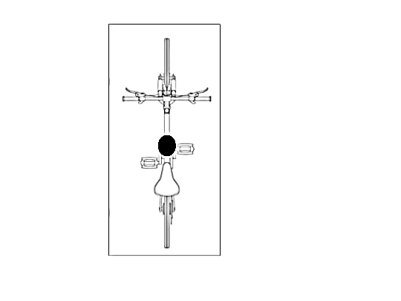

|  |  |  |  |  |  |  |  |  |  |  |  |  |  |  |  |  |  |  |  |  |  |  |  |  |  |  |
| --- | --- | --- | --- | --- | --- | --- | --- | --- | --- | --- | --- | --- | --- | --- | --- | --- | --- | --- | --- | --- | --- | --- | --- | --- | --- | --- |
|  |  |  |  |  |  |  |  |  |  |  |  |  |  |  |  |  |  |  |  |  |  |  |  |  |  |  |
|  |  |  |  |  |  |  |  |  |  |  |  |  |  |  |  |  |  |  |  |  |  |  |  |  |  |  |
|  |  |  |  |  |  |  |  |  |  |  |  |  |  |  |  |  |  |  |  |  |  |  |  |  |  |  |
|  |  |  |  |  |  |  |  |  |  |  |  |  |  |  |  |  |  |  |  |  |  |  |  |  |  |  |
|  |  |  |  |  |  |  |  |  |  |  |  |  |  |  |  |  |  |  |  |  |  |  |  |  |  |  |
|  |  |  |  |  |  |  |  |  |  |  |  |  |  |  |  |  |  |  |  |  |  |  |  |  |  |  |
|  |  |  |  |  |  |  |  |  |  |  |  |  |  |  |  |  |  |  |  |  |  |  |  |  |  |  |
|  |  |  |  |  |  |  |  |  |  |  |  |  |  |  |  |  |  |  |  |  |  |  |  |  |  |  |
|  |  |  |  |  |  |  |  |  |  |  |  |  |  |  |  |  |  |  |  |  |  |  |  |  |  |  |
|  |  |  |  |  |  |  |  |  |  |  |  |  |  |  |  |  |  |  |  |  |  |  |  |  |  |  |
|  |  |  |  |  |  |  |  |  |  |  |  |  |  |  |  |  |  |  |  |  |  |  |  |  |  |  |
|  |  |  |  |  |  |  |  |  |  |  |  |  |  |  |  |  |  |  |  |  |  |  |  |  |  |  |
|  |  |  |  |  |  |  |  |  |  |  |  |  |  |  |  |  |  |  |  |  |  |  |  |  |  |  |
|  |  |  |  |  |  |  |  |  |  |  |  |  |  |  |  |  |  |  |  |  |  |  |  |  |  |  |

**……………….../ 4 pkt.**

(liczba uzyskanych punktów / maksymalna liczba punktów)

**Zadanie nr 3 (0-5 pkt.)**

Odważnik o masie 10 dag zaczął spadać swobodnie z pewnej wysokości.

1. Oblicz szybkość odważnika po dwóch sekundach od rozpoczęcia ruchu.

|  |  |  |  |  |  |  |  |  |  |  |  |  |  |  |  |  |  |  |  |  |  |  |  |  |  |  |
| --- | --- | --- | --- | --- | --- | --- | --- | --- | --- | --- | --- | --- | --- | --- | --- | --- | --- | --- | --- | --- | --- | --- | --- | --- | --- | --- |
|  |  |  |  |  |  |  |  |  |  |  |  |  |  |  |  |  |  |  |  |  |  |  |  |  |  |  |
|  |  |  |  |  |  |  |  |  |  |  |  |  |  |  |  |  |  |  |  |  |  |  |  |  |  |  |
|  |  |  |  |  |  |  |  |  |  |  |  |  |  |  |  |  |  |  |  |  |  |  |  |  |  |  |
|  |  |  |  |  |  |  |  |  |  |  |  |  |  |  |  |  |  |  |  |  |  |  |  |  |  |  |
|  |  |  |  |  |  |  |  |  |  |  |  |  |  |  |  |  |  |  |  |  |  |  |  |  |  |  |
|  |  |  |  |  |  |  |  |  |  |  |  |  |  |  |  |  |  |  |  |  |  |  |  |  |  |  |
|  |  |  |  |  |  |  |  |  |  |  |  |  |  |  |  |  |  |  |  |  |  |  |  |  |  |  |
|  |  |  |  |  |  |  |  |  |  |  |  |  |  |  |  |  |  |  |  |  |  |  |  |  |  |  |
|  |  |  |  |  |  |  |  |  |  |  |  |  |  |  |  |  |  |  |  |  |  |  |  |  |  |  |

1. Oblicz energię kinetyczną odważnika po dwóch sekundach od rozpoczęcia ruchu.

|  |  |  |  |  |  |  |  |  |  |  |  |  |  |  |  |  |  |  |  |  |  |  |  |  |  |  |
| --- | --- | --- | --- | --- | --- | --- | --- | --- | --- | --- | --- | --- | --- | --- | --- | --- | --- | --- | --- | --- | --- | --- | --- | --- | --- | --- |
|  |  |  |  |  |  |  |  |  |  |  |  |  |  |  |  |  |  |  |  |  |  |  |  |  |  |  |
|  |  |  |  |  |  |  |  |  |  |  |  |  |  |  |  |  |  |  |  |  |  |  |  |  |  |  |
|  |  |  |  |  |  |  |  |  |  |  |  |  |  |  |  |  |  |  |  |  |  |  |  |  |  |  |
|  |  |  |  |  |  |  |  |  |  |  |  |  |  |  |  |  |  |  |  |  |  |  |  |  |  |  |
|  |  |  |  |  |  |  |  |  |  |  |  |  |  |  |  |  |  |  |  |  |  |  |  |  |  |  |
|  |  |  |  |  |  |  |  |  |  |  |  |  |  |  |  |  |  |  |  |  |  |  |  |  |  |  |
|  |  |  |  |  |  |  |  |  |  |  |  |  |  |  |  |  |  |  |  |  |  |  |  |  |  |  |
|  |  |  |  |  |  |  |  |  |  |  |  |  |  |  |  |  |  |  |  |  |  |  |  |  |  |  |
|  |  |  |  |  |  |  |  |  |  |  |  |  |  |  |  |  |  |  |  |  |  |  |  |  |  |  |

**……………….../ 5 pkt.**

(liczba uzyskanych punktów / maksymalna liczba punktów)

# Wykres do zadań od 4 do 7.

Na poniższym wykresie przedstawiono zależność temperatury substancji   
od dostarczonego ciepła.

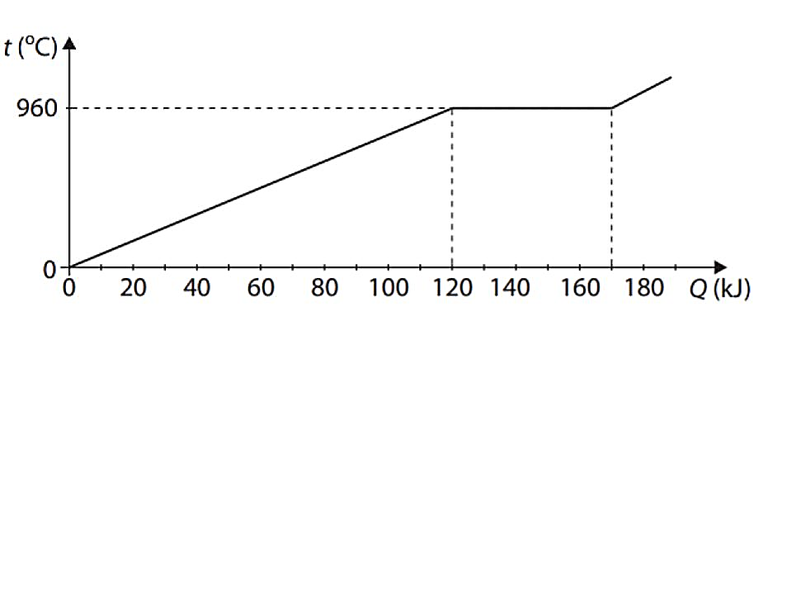

# Zadanie nr 4 (0-1 pkt.)

Zapisz temperaturę topnienia substancji.

|  |  |  |  |  |  |  |  |  |  |  |  |  |  |  |  |  |  |  |  |  |  |  |  |  |  |  |
| --- | --- | --- | --- | --- | --- | --- | --- | --- | --- | --- | --- | --- | --- | --- | --- | --- | --- | --- | --- | --- | --- | --- | --- | --- | --- | --- |
|  |  |  |  |  |  |  |  |  |  |  |  |  |  |  |  |  |  |  |  |  |  |  |  |  |  |  |
|  |  |  |  |  |  |  |  |  |  |  |  |  |  |  |  |  |  |  |  |  |  |  |  |  |  |  |
|  |  |  |  |  |  |  |  |  |  |  |  |  |  |  |  |  |  |  |  |  |  |  |  |  |  |  |

**……………….../ 1 pkt.**

(liczba uzyskanych punktów / maksymalna liczba punktów)

**Zadanie nr 5 (0-1 pkt.)**

Odczytaj z wykresu i napisz, ile ciepła potrzebuje substancja, aby całkowicie   
się roztopić.

|  |  |  |  |  |  |  |  |  |  |  |  |  |  |  |  |  |  |  |  |  |  |  |  |  |  |  |
| --- | --- | --- | --- | --- | --- | --- | --- | --- | --- | --- | --- | --- | --- | --- | --- | --- | --- | --- | --- | --- | --- | --- | --- | --- | --- | --- |
|  |  |  |  |  |  |  |  |  |  |  |  |  |  |  |  |  |  |  |  |  |  |  |  |  |  |  |
|  |  |  |  |  |  |  |  |  |  |  |  |  |  |  |  |  |  |  |  |  |  |  |  |  |  |  |
|  |  |  |  |  |  |  |  |  |  |  |  |  |  |  |  |  |  |  |  |  |  |  |  |  |  |  |

**……………….../ 1 pkt.**

(liczba uzyskanych punktów / maksymalna liczba punktów)

# Zadanie nr 6 (0-3 pkt.)

Oblicz masę substancji, która uległa stopieniu wiedząc, że ciepło topnienia   
wynosi 100 $\frac{kJ}{kg}$.

|  |  |  |  |  |  |  |  |  |  |  |  |  |  |  |  |  |  |  |  |  |  |  |  |  |  |  |
| --- | --- | --- | --- | --- | --- | --- | --- | --- | --- | --- | --- | --- | --- | --- | --- | --- | --- | --- | --- | --- | --- | --- | --- | --- | --- | --- |
|  |  |  |  |  |  |  |  |  |  |  |  |  |  |  |  |  |  |  |  |  |  |  |  |  |  |  |
|  |  |  |  |  |  |  |  |  |  |  |  |  |  |  |  |  |  |  |  |  |  |  |  |  |  |  |
|  |  |  |  |  |  |  |  |  |  |  |  |  |  |  |  |  |  |  |  |  |  |  |  |  |  |  |
|  |  |  |  |  |  |  |  |  |  |  |  |  |  |  |  |  |  |  |  |  |  |  |  |  |  |  |
|  |  |  |  |  |  |  |  |  |  |  |  |  |  |  |  |  |  |  |  |  |  |  |  |  |  |  |

**……………….../ 3 pkt.**

(liczba uzyskanych punktów / maksymalna liczba punktów)

**Zadanie nr 7 (0-1 pkt.)**

Substancja była podgrzewana od 0 °C do 960 °C. Oblicz przyrost temperatury tej substancji w kelwinach.

|  |  |  |  |  |  |  |  |  |  |  |  |  |  |  |  |  |  |  |  |  |  |  |  |  |  |  |
| --- | --- | --- | --- | --- | --- | --- | --- | --- | --- | --- | --- | --- | --- | --- | --- | --- | --- | --- | --- | --- | --- | --- | --- | --- | --- | --- |
|  |  |  |  |  |  |  |  |  |  |  |  |  |  |  |  |  |  |  |  |  |  |  |  |  |  |  |
|  |  |  |  |  |  |  |  |  |  |  |  |  |  |  |  |  |  |  |  |  |  |  |  |  |  |  |
|  |  |  |  |  |  |  |  |  |  |  |  |  |  |  |  |  |  |  |  |  |  |  |  |  |  |  |

**……………….../ 1 pkt.**

(liczba uzyskanych punktów / maksymalna liczba punktów)

# Zadanie nr 8 (0-2 pkt.)

# Na rysunku poniżej przedstawiono trzy naczynia zawierające wodę.

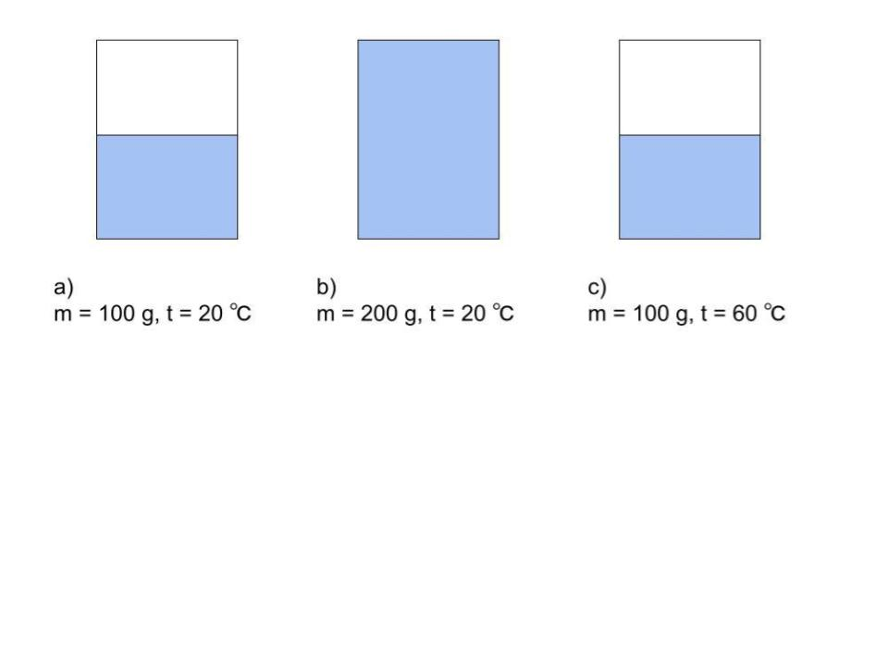

# Wpisz w ramkę przy zdaniu: P, jeżeli jest prawdziwe lub F, jeżeli jest fałszywe.

▯Największą energię wewnętrzną ma woda w naczyniu a).

▯Największą średnią energię kinetyczną mają cząsteczki wody w naczyniu c).

▯Cząsteczki wody w naczyniach a) oraz b) mają tą samą średnią energię   
 kinetyczną.

**……………….../ 2 pkt.**

(liczba uzyskanych punktów / maksymalna liczba punktów)

# Zadanie nr 9 (0-4 pkt.)

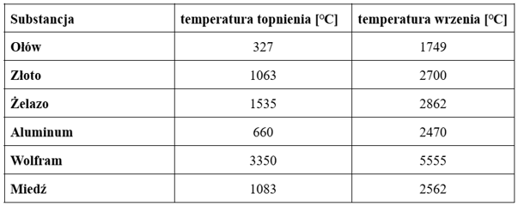Na podstawie informacji przedstawionych w powyższej tabeli uzupełnij zdania wpisując w wykropkowane miejsca nazwę jednego ze stanów skupienia materii.

1. Ołów w temperaturze 1600 °C jest w ...................................... stanie skupienia.
2. Wolfram w temperaturze 2000 °C jest w ................................. stanie skupienia.
3. Żelazo w temperaturze 2964 °C jest w ....................................stanie skupienia.

Na podstawie informacji przedstawionych w powyższej tabeli odpowiedz na pytanie wraz z uzasadnieniem.

Czy można roztopić żelazo w piecu wykonanym ze złota?

|  |  |  |  |  |  |  |  |  |  |  |  |  |  |  |  |  |  |  |  |  |  |  |  |  |  |  |
| --- | --- | --- | --- | --- | --- | --- | --- | --- | --- | --- | --- | --- | --- | --- | --- | --- | --- | --- | --- | --- | --- | --- | --- | --- | --- | --- |
|  |  |  |  |  |  |  |  |  |  |  |  |  |  |  |  |  |  |  |  |  |  |  |  |  |  |  |
|  |  |  |  |  |  |  |  |  |  |  |  |  |  |  |  |  |  |  |  |  |  |  |  |  |  |  |
|  |  |  |  |  |  |  |  |  |  |  |  |  |  |  |  |  |  |  |  |  |  |  |  |  |  |  |
|  |  |  |  |  |  |  |  |  |  |  |  |  |  |  |  |  |  |  |  |  |  |  |  |  |  |  |
|  |  |  |  |  |  |  |  |  |  |  |  |  |  |  |  |  |  |  |  |  |  |  |  |  |  |  |

**……………….../ 4 pkt.**

(liczba uzyskanych punktów / maksymalna liczba punktów)

# Zadanie nr 10 (0-2 pkt.)

Uzupełnij zdania wpisując nazwę procesu zmiany stanu skupienia materii i podkreśl jeden z wyrazów podanych w nawiasie tak, aby zdania były prawdziwe.

1. Zmiana stanu skupienia ze stanu stałego w stan gazowy   
   to ........................................ Podczas tego procesu substancja  
   (pobiera / oddaje) energię.
2. Zmiana stanu skupienia ze stanu gazowego w stan ciekły   
   to ........................................ Podczas tego procesu substancja  
   (pobiera / oddaje) energię.

**……………….../ 2 pkt.**

(liczba uzyskanych punktów / maksymalna liczba punktów)

# Zadanie nr 11 (0-1 pkt.)

Na czerwono pomalowano magnes sztabkowy oraz identycznie wyglądającą sztabkę żelaza. Napisz, jak można zademonstrować, które z nich to magnes, a które to sztabka żelaza. Możesz użyć tylko magnesu oraz sztabki żelaza.

|  |  |  |  |  |  |  |  |  |  |  |  |  |  |  |  |  |  |  |  |  |  |  |  |  |  |  |
| --- | --- | --- | --- | --- | --- | --- | --- | --- | --- | --- | --- | --- | --- | --- | --- | --- | --- | --- | --- | --- | --- | --- | --- | --- | --- | --- |
|  |  |  |  |  |  |  |  |  |  |  |  |  |  |  |  |  |  |  |  |  |  |  |  |  |  |  |
|  |  |  |  |  |  |  |  |  |  |  |  |  |  |  |  |  |  |  |  |  |  |  |  |  |  |  |
|  |  |  |  |  |  |  |  |  |  |  |  |  |  |  |  |  |  |  |  |  |  |  |  |  |  |  |
|  |  |  |  |  |  |  |  |  |  |  |  |  |  |  |  |  |  |  |  |  |  |  |  |  |  |  |
|  |  |  |  |  |  |  |  |  |  |  |  |  |  |  |  |  |  |  |  |  |  |  |  |  |  |  |
|  |  |  |  |  |  |  |  |  |  |  |  |  |  |  |  |  |  |  |  |  |  |  |  |  |  |  |
|  |  |  |  |  |  |  |  |  |  |  |  |  |  |  |  |  |  |  |  |  |  |  |  |  |  |  |
|  |  |  |  |  |  |  |  |  |  |  |  |  |  |  |  |  |  |  |  |  |  |  |  |  |  |  |
|  |  |  |  |  |  |  |  |  |  |  |  |  |  |  |  |  |  |  |  |  |  |  |  |  |  |  |
|  |  |  |  |  |  |  |  |  |  |  |  |  |  |  |  |  |  |  |  |  |  |  |  |  |  |  |
|  |  |  |  |  |  |  |  |  |  |  |  |  |  |  |  |  |  |  |  |  |  |  |  |  |  |  |
|  |  |  |  |  |  |  |  |  |  |  |  |  |  |  |  |  |  |  |  |  |  |  |  |  |  |  |
|  |  |  |  |  |  |  |  |  |  |  |  |  |  |  |  |  |  |  |  |  |  |  |  |  |  |  |
|  |  |  |  |  |  |  |  |  |  |  |  |  |  |  |  |  |  |  |  |  |  |  |  |  |  |  |
|  |  |  |  |  |  |  |  |  |  |  |  |  |  |  |  |  |  |  |  |  |  |  |  |  |  |  |
|  |  |  |  |  |  |  |  |  |  |  |  |  |  |  |  |  |  |  |  |  |  |  |  |  |  |  |
|  |  |  |  |  |  |  |  |  |  |  |  |  |  |  |  |  |  |  |  |  |  |  |  |  |  |  |
|  |  |  |  |  |  |  |  |  |  |  |  |  |  |  |  |  |  |  |  |  |  |  |  |  |  |  |
|  |  |  |  |  |  |  |  |  |  |  |  |  |  |  |  |  |  |  |  |  |  |  |  |  |  |  |
|  |  |  |  |  |  |  |  |  |  |  |  |  |  |  |  |  |  |  |  |  |  |  |  |  |  |  |
|  |  |  |  |  |  |  |  |  |  |  |  |  |  |  |  |  |  |  |  |  |  |  |  |  |  |  |
|  |  |  |  |  |  |  |  |  |  |  |  |  |  |  |  |  |  |  |  |  |  |  |  |  |  |  |
|  |  |  |  |  |  |  |  |  |  |  |  |  |  |  |  |  |  |  |  |  |  |  |  |  |  |  |

**……………….../ 1 pkt.**

(liczba uzyskanych punktów / maksymalna liczba punktów)

# Zadanie nr 12 (0-1 pkt.)

Wybierz poprawne dokończenie zdania 1-2 oraz uzasadnienie a-b.

Dwa magnesy zbliżamy do siebie biegunami jednoimiennymi. Magnesy będą się:

|  |  |  |
| --- | --- | --- |
| 1. przyciągać | zgodnie z | a. III zasadą dynamiki  Newtona. |
| 1. odpychać | b. I zasadą dynamiki   Newtona. |

**……………….../ 1 pkt.**

(liczba uzyskanych punktów / maksymalna liczba punktów)

# Zadanie nr 13 (0-6 pkt.)

Uczniowie wykonali doświadczenie z igłą magnetyczną w otoczeniu prostoliniowego przewodnika, przez który płynie prąd elektryczny (patrz rysunki).

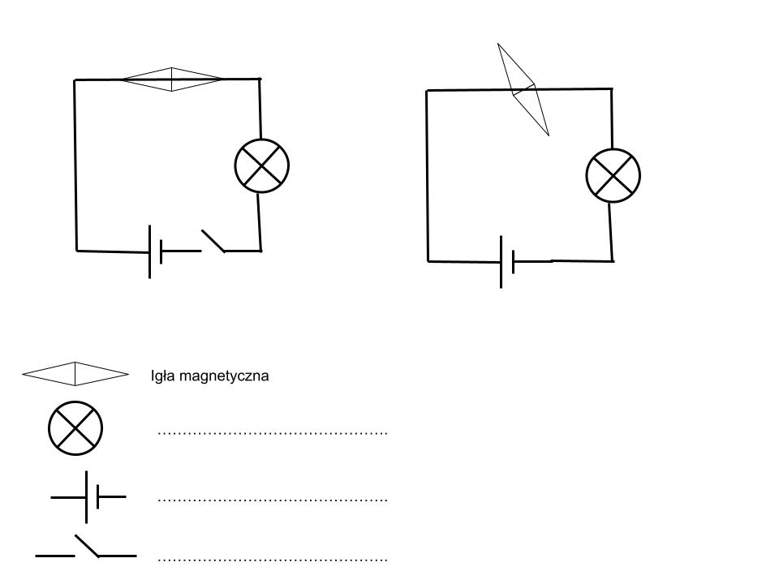

Na podstawie rysunków wykonaj polecenia.

1. Wpisz nazwy elementów obwodów przedstawionych na rysunkach w miejsce przerywanych linii.
2. Napisz, co zaobserwowali uczniowie, gdy obwód został zamknięty.

|  |  |  |  |  |  |  |  |  |  |  |  |  |  |  |  |  |  |  |  |  |  |  |  |  |  |  |
| --- | --- | --- | --- | --- | --- | --- | --- | --- | --- | --- | --- | --- | --- | --- | --- | --- | --- | --- | --- | --- | --- | --- | --- | --- | --- | --- |
|  |  |  |  |  |  |  |  |  |  |  |  |  |  |  |  |  |  |  |  |  |  |  |  |  |  |  |
|  |  |  |  |  |  |  |  |  |  |  |  |  |  |  |  |  |  |  |  |  |  |  |  |  |  |  |
|  |  |  |  |  |  |  |  |  |  |  |  |  |  |  |  |  |  |  |  |  |  |  |  |  |  |  |

1. Opisz i wyjaśnij zachowanie igły magnetycznej po zamknięciu obwodu.

|  |  |  |  |  |  |  |  |  |  |  |  |  |  |  |  |  |  |  |  |  |  |  |  |  |  |  |
| --- | --- | --- | --- | --- | --- | --- | --- | --- | --- | --- | --- | --- | --- | --- | --- | --- | --- | --- | --- | --- | --- | --- | --- | --- | --- | --- |
|  |  |  |  |  |  |  |  |  |  |  |  |  |  |  |  |  |  |  |  |  |  |  |  |  |  |  |
|  |  |  |  |  |  |  |  |  |  |  |  |  |  |  |  |  |  |  |  |  |  |  |  |  |  |  |
|  |  |  |  |  |  |  |  |  |  |  |  |  |  |  |  |  |  |  |  |  |  |  |  |  |  |  |
|  |  |  |  |  |  |  |  |  |  |  |  |  |  |  |  |  |  |  |  |  |  |  |  |  |  |  |
|  |  |  |  |  |  |  |  |  |  |  |  |  |  |  |  |  |  |  |  |  |  |  |  |  |  |  |
|  |  |  |  |  |  |  |  |  |  |  |  |  |  |  |  |  |  |  |  |  |  |  |  |  |  |  |
|  |  |  |  |  |  |  |  |  |  |  |  |  |  |  |  |  |  |  |  |  |  |  |  |  |  |  |
|  |  |  |  |  |  |  |  |  |  |  |  |  |  |  |  |  |  |  |  |  |  |  |  |  |  |  |
|  |  |  |  |  |  |  |  |  |  |  |  |  |  |  |  |  |  |  |  |  |  |  |  |  |  |  |

**……………….../ 6 pkt.**

(liczba uzyskanych punktów / maksymalna liczba punktów)

# Zadanie nr 14 (0-12 pkt.)

Walec o promieniu 2 cm i wysokości 6 cm wykonany jest z aluminium   
o gęstości 2700 $\frac{kg}{m^{3}}$. Walec jest zanurzony do połowy swojej objętości w wodzie   
o gęstości 1000 $\frac{kg}{m^{3}}$. Przyjmij, że π = 3,14.

1. Oblicz objętość walca.

|  |  |  |  |  |  |  |  |  |  |  |  |  |  |  |  |  |  |  |  |  |  |  |  |  |  |  |
| --- | --- | --- | --- | --- | --- | --- | --- | --- | --- | --- | --- | --- | --- | --- | --- | --- | --- | --- | --- | --- | --- | --- | --- | --- | --- | --- |
|  |  |  |  |  |  |  |  |  |  |  |  |  |  |  |  |  |  |  |  |  |  |  |  |  |  |  |
|  |  |  |  |  |  |  |  |  |  |  |  |  |  |  |  |  |  |  |  |  |  |  |  |  |  |  |
|  |  |  |  |  |  |  |  |  |  |  |  |  |  |  |  |  |  |  |  |  |  |  |  |  |  |  |
|  |  |  |  |  |  |  |  |  |  |  |  |  |  |  |  |  |  |  |  |  |  |  |  |  |  |  |
|  |  |  |  |  |  |  |  |  |  |  |  |  |  |  |  |  |  |  |  |  |  |  |  |  |  |  |
|  |  |  |  |  |  |  |  |  |  |  |  |  |  |  |  |  |  |  |  |  |  |  |  |  |  |  |

1. Oblicz masę walca. Wynik podaj z dokładnością do cyfry części dziesiętnych.

|  |  |  |  |  |  |  |  |  |  |  |  |  |  |  |  |  |  |  |  |  |  |  |  |  |  |  |
| --- | --- | --- | --- | --- | --- | --- | --- | --- | --- | --- | --- | --- | --- | --- | --- | --- | --- | --- | --- | --- | --- | --- | --- | --- | --- | --- |
|  |  |  |  |  |  |  |  |  |  |  |  |  |  |  |  |  |  |  |  |  |  |  |  |  |  |  |
|  |  |  |  |  |  |  |  |  |  |  |  |  |  |  |  |  |  |  |  |  |  |  |  |  |  |  |
|  |  |  |  |  |  |  |  |  |  |  |  |  |  |  |  |  |  |  |  |  |  |  |  |  |  |  |
|  |  |  |  |  |  |  |  |  |  |  |  |  |  |  |  |  |  |  |  |  |  |  |  |  |  |  |
|  |  |  |  |  |  |  |  |  |  |  |  |  |  |  |  |  |  |  |  |  |  |  |  |  |  |  |

1. Oblicz wartość siły, z jaką walec przyciągany jest przez Ziemię. Wynik podaj   
   z dokładnością do cyfry części dziesiętnych.

|  |  |  |  |  |  |  |  |  |  |  |  |  |  |  |  |  |  |  |  |  |  |  |  |  |  |  |
| --- | --- | --- | --- | --- | --- | --- | --- | --- | --- | --- | --- | --- | --- | --- | --- | --- | --- | --- | --- | --- | --- | --- | --- | --- | --- | --- |
|  |  |  |  |  |  |  |  |  |  |  |  |  |  |  |  |  |  |  |  |  |  |  |  |  |  |  |
|  |  |  |  |  |  |  |  |  |  |  |  |  |  |  |  |  |  |  |  |  |  |  |  |  |  |  |
|  |  |  |  |  |  |  |  |  |  |  |  |  |  |  |  |  |  |  |  |  |  |  |  |  |  |  |
|  |  |  |  |  |  |  |  |  |  |  |  |  |  |  |  |  |  |  |  |  |  |  |  |  |  |  |

1. Oblicz wartość siły wyporu, jaka działa na walec zanurzony w wodzie. Wynik podaj z dokładnością do cyfry części dziesiętnych.

|  |  |  |  |  |  |  |  |  |  |  |  |  |  |  |  |  |  |  |  |  |  |  |  |  |  |  |
| --- | --- | --- | --- | --- | --- | --- | --- | --- | --- | --- | --- | --- | --- | --- | --- | --- | --- | --- | --- | --- | --- | --- | --- | --- | --- | --- |
|  |  |  |  |  |  |  |  |  |  |  |  |  |  |  |  |  |  |  |  |  |  |  |  |  |  |  |
|  |  |  |  |  |  |  |  |  |  |  |  |  |  |  |  |  |  |  |  |  |  |  |  |  |  |  |
|  |  |  |  |  |  |  |  |  |  |  |  |  |  |  |  |  |  |  |  |  |  |  |  |  |  |  |
|  |  |  |  |  |  |  |  |  |  |  |  |  |  |  |  |  |  |  |  |  |  |  |  |  |  |  |
|  |  |  |  |  |  |  |  |  |  |  |  |  |  |  |  |  |  |  |  |  |  |  |  |  |  |  |
|  |  |  |  |  |  |  |  |  |  |  |  |  |  |  |  |  |  |  |  |  |  |  |  |  |  |  |
|  |  |  |  |  |  |  |  |  |  |  |  |  |  |  |  |  |  |  |  |  |  |  |  |  |  |  |
|  |  |  |  |  |  |  |  |  |  |  |  |  |  |  |  |  |  |  |  |  |  |  |  |  |  |  |
|  |  |  |  |  |  |  |  |  |  |  |  |  |  |  |  |  |  |  |  |  |  |  |  |  |  |  |

1. Oblicz wartość siły wypadkowej z sił (siły grawitacji i siły wyporu) działających na walec zanurzony w wodzie.

|  |  |  |  |  |  |  |  |  |  |  |  |  |  |  |  |  |  |  |  |  |  |  |  |  |  |  |
| --- | --- | --- | --- | --- | --- | --- | --- | --- | --- | --- | --- | --- | --- | --- | --- | --- | --- | --- | --- | --- | --- | --- | --- | --- | --- | --- |
|  |  |  |  |  |  |  |  |  |  |  |  |  |  |  |  |  |  |  |  |  |  |  |  |  |  |  |
|  |  |  |  |  |  |  |  |  |  |  |  |  |  |  |  |  |  |  |  |  |  |  |  |  |  |  |
|  |  |  |  |  |  |  |  |  |  |  |  |  |  |  |  |  |  |  |  |  |  |  |  |  |  |  |

**……………….../ 12 pkt.**

(liczba uzyskanych punktów / maksymalna liczba punktów)

# Zadanie nr 15 (0-4 pkt.)

Do trzech naczyń o tej samej masie oraz polu powierzchni dna, nalano wody do tej samej wysokości. Naczynia ustawiono na stole. Sytuację prezentuje rysunek.

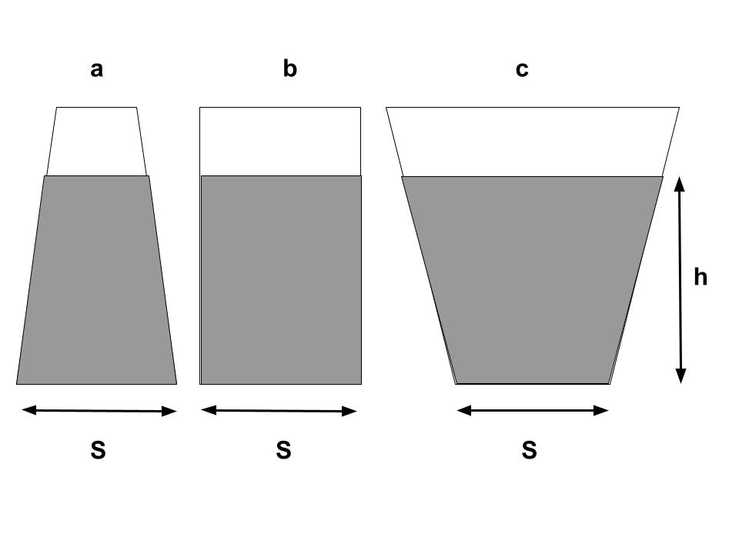

Wstaw odpowiedni znak relacji między wielkościami: <, =, >

1. Masy porcji wody w naczyniach:

ma ............ mb ............. mc

1. Siły, z jakimi naczynia z wodą naciskają na blat stołu:

FNa ............ FNb ............. FNc

1. Ciśnienia tuż przy dnie naczyń:

pa ............ pb ............. pc

1. Siły parcia na dno naczyń:

Fa ............ Fb ............. Fc

**……………….../ 4 pkt.**

(liczba uzyskanych punktów / maksymalna liczba punktów)

# Zadanie nr 16 (0-7 pkt.)

Śrut o masie 8 g został wystrzelony z poziomo ustawionej wiatrówki w kierunku puszki po napoju ustawionej na drewnianej desce. Gdy śrut miał szybkość 7 $\frac{m}{s}$, przebił ściankę puszki o masie 20 g i wpadł do jej środka. Puszka wraz ze śrutem przesunęła się w poziomie na odległość 2 m po drewnianej desce. Zakładając,   
że nie było straty energii na ciepło, a śrut się zatrzymał, oblicz współczynnik tarcia metalowej puszki o drewno.

|  |  |  |  |  |  |  |  |  |  |  |  |  |  |  |  |  |  |  |  |  |  |  |  |  |  |  |
| --- | --- | --- | --- | --- | --- | --- | --- | --- | --- | --- | --- | --- | --- | --- | --- | --- | --- | --- | --- | --- | --- | --- | --- | --- | --- | --- |
|  |  |  |  |  |  |  |  |  |  |  |  |  |  |  |  |  |  |  |  |  |  |  |  |  |  |  |
|  |  |  |  |  |  |  |  |  |  |  |  |  |  |  |  |  |  |  |  |  |  |  |  |  |  |  |
|  |  |  |  |  |  |  |  |  |  |  |  |  |  |  |  |  |  |  |  |  |  |  |  |  |  |  |
|  |  |  |  |  |  |  |  |  |  |  |  |  |  |  |  |  |  |  |  |  |  |  |  |  |  |  |
|  |  |  |  |  |  |  |  |  |  |  |  |  |  |  |  |  |  |  |  |  |  |  |  |  |  |  |
|  |  |  |  |  |  |  |  |  |  |  |  |  |  |  |  |  |  |  |  |  |  |  |  |  |  |  |
|  |  |  |  |  |  |  |  |  |  |  |  |  |  |  |  |  |  |  |  |  |  |  |  |  |  |  |
|  |  |  |  |  |  |  |  |  |  |  |  |  |  |  |  |  |  |  |  |  |  |  |  |  |  |  |
|  |  |  |  |  |  |  |  |  |  |  |  |  |  |  |  |  |  |  |  |  |  |  |  |  |  |  |
|  |  |  |  |  |  |  |  |  |  |  |  |  |  |  |  |  |  |  |  |  |  |  |  |  |  |  |
|  |  |  |  |  |  |  |  |  |  |  |  |  |  |  |  |  |  |  |  |  |  |  |  |  |  |  |
|  |  |  |  |  |  |  |  |  |  |  |  |  |  |  |  |  |  |  |  |  |  |  |  |  |  |  |
|  |  |  |  |  |  |  |  |  |  |  |  |  |  |  |  |  |  |  |  |  |  |  |  |  |  |  |
|  |  |  |  |  |  |  |  |  |  |  |  |  |  |  |  |  |  |  |  |  |  |  |  |  |  |  |
|  |  |  |  |  |  |  |  |  |  |  |  |  |  |  |  |  |  |  |  |  |  |  |  |  |  |  |
|  |  |  |  |  |  |  |  |  |  |  |  |  |  |  |  |  |  |  |  |  |  |  |  |  |  |  |
|  |  |  |  |  |  |  |  |  |  |  |  |  |  |  |  |  |  |  |  |  |  |  |  |  |  |  |
|  |  |  |  |  |  |  |  |  |  |  |  |  |  |  |  |  |  |  |  |  |  |  |  |  |  |  |
|  |  |  |  |  |  |  |  |  |  |  |  |  |  |  |  |  |  |  |  |  |  |  |  |  |  |  |
|  |  |  |  |  |  |  |  |  |  |  |  |  |  |  |  |  |  |  |  |  |  |  |  |  |  |  |
|  |  |  |  |  |  |  |  |  |  |  |  |  |  |  |  |  |  |  |  |  |  |  |  |  |  |  |
|  |  |  |  |  |  |  |  |  |  |  |  |  |  |  |  |  |  |  |  |  |  |  |  |  |  |  |
|  |  |  |  |  |  |  |  |  |  |  |  |  |  |  |  |  |  |  |  |  |  |  |  |  |  |  |

**……………….../ 7 pkt.**

(liczba uzyskanych punktów / maksymalna liczba punktów)

# Zadanie nr 17 (0-5 pkt.)

Na międzynarodowej stacji kosmicznej (International Space Station) dwaj astronauci o masach $m_{1}$ = 60 kg oraz $m_{2}$ = 80 kg odepchnęli się od siebie, tak że pierwszy poleciał w lewo, a drugi w prawo. Wykonaj poniższe polecenia.

1. Napisz, która zasada dynamiki Newtona opisuje powyższą sytuację.

|  |  |  |  |  |  |  |  |  |  |  |  |  |  |  |  |  |  |  |  |  |  |  |  |  |  |  |
| --- | --- | --- | --- | --- | --- | --- | --- | --- | --- | --- | --- | --- | --- | --- | --- | --- | --- | --- | --- | --- | --- | --- | --- | --- | --- | --- |
|  |  |  |  |  |  |  |  |  |  |  |  |  |  |  |  |  |  |  |  |  |  |  |  |  |  |  |
|  |  |  |  |  |  |  |  |  |  |  |  |  |  |  |  |  |  |  |  |  |  |  |  |  |  |  |
|  |  |  |  |  |  |  |  |  |  |  |  |  |  |  |  |  |  |  |  |  |  |  |  |  |  |  |

1. Oblicz wartość przyspieszenia pierwszego astronauty wiedząc, że uzyskał   
   on szybkość 9 $\frac{km}{h}$ w czasie 2 s.

|  |  |  |  |  |  |  |  |  |  |  |  |  |  |  |  |  |  |  |  |  |  |  |  |  |  |  |
| --- | --- | --- | --- | --- | --- | --- | --- | --- | --- | --- | --- | --- | --- | --- | --- | --- | --- | --- | --- | --- | --- | --- | --- | --- | --- | --- |
|  |  |  |  |  |  |  |  |  |  |  |  |  |  |  |  |  |  |  |  |  |  |  |  |  |  |  |
|  |  |  |  |  |  |  |  |  |  |  |  |  |  |  |  |  |  |  |  |  |  |  |  |  |  |  |
|  |  |  |  |  |  |  |  |  |  |  |  |  |  |  |  |  |  |  |  |  |  |  |  |  |  |  |
|  |  |  |  |  |  |  |  |  |  |  |  |  |  |  |  |  |  |  |  |  |  |  |  |  |  |  |
|  |  |  |  |  |  |  |  |  |  |  |  |  |  |  |  |  |  |  |  |  |  |  |  |  |  |  |
|  |  |  |  |  |  |  |  |  |  |  |  |  |  |  |  |  |  |  |  |  |  |  |  |  |  |  |
|  |  |  |  |  |  |  |  |  |  |  |  |  |  |  |  |  |  |  |  |  |  |  |  |  |  |  |
|  |  |  |  |  |  |  |  |  |  |  |  |  |  |  |  |  |  |  |  |  |  |  |  |  |  |  |
|  |  |  |  |  |  |  |  |  |  |  |  |  |  |  |  |  |  |  |  |  |  |  |  |  |  |  |

1. Oblicz wartość siły, z jaką odepchnął się jeden astronauta od drugiego.

|  |  |  |  |  |  |  |  |  |  |  |  |  |  |  |  |  |  |  |  |  |  |  |  |  |  |  |
| --- | --- | --- | --- | --- | --- | --- | --- | --- | --- | --- | --- | --- | --- | --- | --- | --- | --- | --- | --- | --- | --- | --- | --- | --- | --- | --- |
|  |  |  |  |  |  |  |  |  |  |  |  |  |  |  |  |  |  |  |  |  |  |  |  |  |  |  |
|  |  |  |  |  |  |  |  |  |  |  |  |  |  |  |  |  |  |  |  |  |  |  |  |  |  |  |
|  |  |  |  |  |  |  |  |  |  |  |  |  |  |  |  |  |  |  |  |  |  |  |  |  |  |  |
|  |  |  |  |  |  |  |  |  |  |  |  |  |  |  |  |  |  |  |  |  |  |  |  |  |  |  |
|  |  |  |  |  |  |  |  |  |  |  |  |  |  |  |  |  |  |  |  |  |  |  |  |  |  |  |

1. Oblicz wartość przyspieszenia drugiego astronauty.

|  |  |  |  |  |  |  |  |  |  |  |  |  |  |  |  |  |  |  |  |  |  |  |  |  |  |  |
| --- | --- | --- | --- | --- | --- | --- | --- | --- | --- | --- | --- | --- | --- | --- | --- | --- | --- | --- | --- | --- | --- | --- | --- | --- | --- | --- |
|  |  |  |  |  |  |  |  |  |  |  |  |  |  |  |  |  |  |  |  |  |  |  |  |  |  |  |
|  |  |  |  |  |  |  |  |  |  |  |  |  |  |  |  |  |  |  |  |  |  |  |  |  |  |  |
|  |  |  |  |  |  |  |  |  |  |  |  |  |  |  |  |  |  |  |  |  |  |  |  |  |  |  |
|  |  |  |  |  |  |  |  |  |  |  |  |  |  |  |  |  |  |  |  |  |  |  |  |  |  |  |
|  |  |  |  |  |  |  |  |  |  |  |  |  |  |  |  |  |  |  |  |  |  |  |  |  |  |  |

**……………….../ 5 pkt.**

(liczba uzyskanych punktów / maksymalna liczba punktów)

# Zadanie nr 18 (0-2 pkt.)

W trakcie pocierania balonu o wełnianą szmatkę, balon zgromadził ładunek   
o wartości 8 nC. Wiedząc, że ładunek elementarny ma wartość 1,6 • ${10}^{-19}$ C, oblicz ilość elektronów, jakiej odpowiada ten ładunek.

|  |  |  |  |  |  |  |  |  |  |  |  |  |  |  |  |  |  |  |  |  |  |  |  |  |  |  |
| --- | --- | --- | --- | --- | --- | --- | --- | --- | --- | --- | --- | --- | --- | --- | --- | --- | --- | --- | --- | --- | --- | --- | --- | --- | --- | --- |
|  |  |  |  |  |  |  |  |  |  |  |  |  |  |  |  |  |  |  |  |  |  |  |  |  |  |  |
|  |  |  |  |  |  |  |  |  |  |  |  |  |  |  |  |  |  |  |  |  |  |  |  |  |  |  |
|  |  |  |  |  |  |  |  |  |  |  |  |  |  |  |  |  |  |  |  |  |  |  |  |  |  |  |
|  |  |  |  |  |  |  |  |  |  |  |  |  |  |  |  |  |  |  |  |  |  |  |  |  |  |  |
|  |  |  |  |  |  |  |  |  |  |  |  |  |  |  |  |  |  |  |  |  |  |  |  |  |  |  |
|  |  |  |  |  |  |  |  |  |  |  |  |  |  |  |  |  |  |  |  |  |  |  |  |  |  |  |

**……………….../ 2 pkt.**

(liczba uzyskanych punktów / maksymalna liczba punktów)

# Zadanie nr 19 (0-1 pkt.)

Na podstawie zachowania się balonów (patrz rysunek) zaznacz, jakich znaków są ładunki zgromadzone na balonach.

▯Tego samego znaku.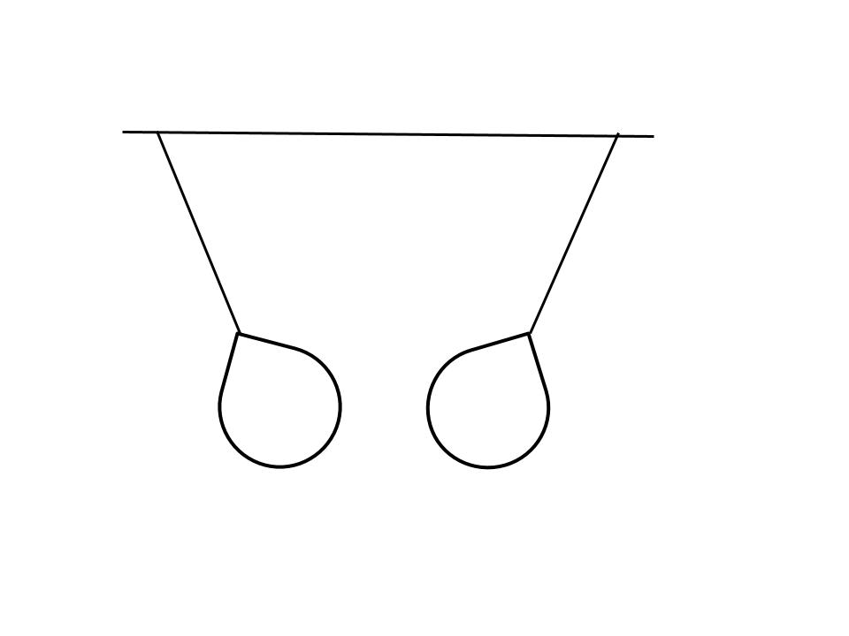

▯Różnych znaków.

▯Balony nie są naładowane.

**……………….../ 1 pkt.**

(liczba uzyskanych punktów / maksymalna liczba punktów)

# Zadanie nr 20 (0-5 pkt.)

Pojemność baterii telefonu komórkowego ma wartość 6 Ah. Oblicz, ile czasu może być użytkowany telefon, gdy przez baterię przepływa prąd o wartości natężenia   
300 mA.

|  |  |  |  |  |  |  |  |  |  |  |  |  |  |  |  |  |  |  |  |  |  |  |  |  |  |  |
| --- | --- | --- | --- | --- | --- | --- | --- | --- | --- | --- | --- | --- | --- | --- | --- | --- | --- | --- | --- | --- | --- | --- | --- | --- | --- | --- |
|  |  |  |  |  |  |  |  |  |  |  |  |  |  |  |  |  |  |  |  |  |  |  |  |  |  |  |
|  |  |  |  |  |  |  |  |  |  |  |  |  |  |  |  |  |  |  |  |  |  |  |  |  |  |  |
|  |  |  |  |  |  |  |  |  |  |  |  |  |  |  |  |  |  |  |  |  |  |  |  |  |  |  |
|  |  |  |  |  |  |  |  |  |  |  |  |  |  |  |  |  |  |  |  |  |  |  |  |  |  |  |
|  |  |  |  |  |  |  |  |  |  |  |  |  |  |  |  |  |  |  |  |  |  |  |  |  |  |  |
|  |  |  |  |  |  |  |  |  |  |  |  |  |  |  |  |  |  |  |  |  |  |  |  |  |  |  |
|  |  |  |  |  |  |  |  |  |  |  |  |  |  |  |  |  |  |  |  |  |  |  |  |  |  |  |
|  |  |  |  |  |  |  |  |  |  |  |  |  |  |  |  |  |  |  |  |  |  |  |  |  |  |  |
|  |  |  |  |  |  |  |  |  |  |  |  |  |  |  |  |  |  |  |  |  |  |  |  |  |  |  |
|  |  |  |  |  |  |  |  |  |  |  |  |  |  |  |  |  |  |  |  |  |  |  |  |  |  |  |

**……………….../ 5 pkt.**

(liczba uzyskanych punktów / maksymalna liczba punktów)

# Zadanie nr 21 (0-4pkt.)

Oblicz opór przewodnika o mocy 60 W, jeżeli przepływa przez niego prąd o wartości natężenia 2 A.

|  |  |  |  |  |  |  |  |  |  |  |  |  |  |  |  |  |  |  |  |  |  |  |  |  |  |  |
| --- | --- | --- | --- | --- | --- | --- | --- | --- | --- | --- | --- | --- | --- | --- | --- | --- | --- | --- | --- | --- | --- | --- | --- | --- | --- | --- |
|  |  |  |  |  |  |  |  |  |  |  |  |  |  |  |  |  |  |  |  |  |  |  |  |  |  |  |
|  |  |  |  |  |  |  |  |  |  |  |  |  |  |  |  |  |  |  |  |  |  |  |  |  |  |  |
|  |  |  |  |  |  |  |  |  |  |  |  |  |  |  |  |  |  |  |  |  |  |  |  |  |  |  |
|  |  |  |  |  |  |  |  |  |  |  |  |  |  |  |  |  |  |  |  |  |  |  |  |  |  |  |
|  |  |  |  |  |  |  |  |  |  |  |  |  |  |  |  |  |  |  |  |  |  |  |  |  |  |  |
|  |  |  |  |  |  |  |  |  |  |  |  |  |  |  |  |  |  |  |  |  |  |  |  |  |  |  |
|  |  |  |  |  |  |  |  |  |  |  |  |  |  |  |  |  |  |  |  |  |  |  |  |  |  |  |
|  |  |  |  |  |  |  |  |  |  |  |  |  |  |  |  |  |  |  |  |  |  |  |  |  |  |  |
|  |  |  |  |  |  |  |  |  |  |  |  |  |  |  |  |  |  |  |  |  |  |  |  |  |  |  |
|  |  |  |  |  |  |  |  |  |  |  |  |  |  |  |  |  |  |  |  |  |  |  |  |  |  |  |
|  |  |  |  |  |  |  |  |  |  |  |  |  |  |  |  |  |  |  |  |  |  |  |  |  |  |  |
|  |  |  |  |  |  |  |  |  |  |  |  |  |  |  |  |  |  |  |  |  |  |  |  |  |  |  |
|  |  |  |  |  |  |  |  |  |  |  |  |  |  |  |  |  |  |  |  |  |  |  |  |  |  |  |
|  |  |  |  |  |  |  |  |  |  |  |  |  |  |  |  |  |  |  |  |  |  |  |  |  |  |  |
|  |  |  |  |  |  |  |  |  |  |  |  |  |  |  |  |  |  |  |  |  |  |  |  |  |  |  |
|  |  |  |  |  |  |  |  |  |  |  |  |  |  |  |  |  |  |  |  |  |  |  |  |  |  |  |
|  |  |  |  |  |  |  |  |  |  |  |  |  |  |  |  |  |  |  |  |  |  |  |  |  |  |  |
|  |  |  |  |  |  |  |  |  |  |  |  |  |  |  |  |  |  |  |  |  |  |  |  |  |  |  |
|  |  |  |  |  |  |  |  |  |  |  |  |  |  |  |  |  |  |  |  |  |  |  |  |  |  |  |
|  |  |  |  |  |  |  |  |  |  |  |  |  |  |  |  |  |  |  |  |  |  |  |  |  |  |  |
|  |  |  |  |  |  |  |  |  |  |  |  |  |  |  |  |  |  |  |  |  |  |  |  |  |  |  |
|  |  |  |  |  |  |  |  |  |  |  |  |  |  |  |  |  |  |  |  |  |  |  |  |  |  |  |

**……………….../ 4 pkt.**

(liczba uzyskanych punktów / maksymalna liczba punktów)

**Brudnopis**

|  |  |  |  |  |  |  |  |  |  |  |  |  |  |  |  |  |  |  |  |  |  |  |  |  |  |  |
| --- | --- | --- | --- | --- | --- | --- | --- | --- | --- | --- | --- | --- | --- | --- | --- | --- | --- | --- | --- | --- | --- | --- | --- | --- | --- | --- |
|  |  |  |  |  |  |  |  |  |  |  |  |  |  |  |  |  |  |  |  |  |  |  |  |  |  |  |
|  |  |  |  |  |  |  |  |  |  |  |  |  |  |  |  |  |  |  |  |  |  |  |  |  |  |  |
|  |  |  |  |  |  |  |  |  |  |  |  |  |  |  |  |  |  |  |  |  |  |  |  |  |  |  |
|  |  |  |  |  |  |  |  |  |  |  |  |  |  |  |  |  |  |  |  |  |  |  |  |  |  |  |
|  |  |  |  |  |  |  |  |  |  |  |  |  |  |  |  |  |  |  |  |  |  |  |  |  |  |  |
|  |  |  |  |  |  |  |  |  |  |  |  |  |  |  |  |  |  |  |  |  |  |  |  |  |  |  |
|  |  |  |  |  |  |  |  |  |  |  |  |  |  |  |  |  |  |  |  |  |  |  |  |  |  |  |
|  |  |  |  |  |  |  |  |  |  |  |  |  |  |  |  |  |  |  |  |  |  |  |  |  |  |  |
|  |  |  |  |  |  |  |  |  |  |  |  |  |  |  |  |  |  |  |  |  |  |  |  |  |  |  |
|  |  |  |  |  |  |  |  |  |  |  |  |  |  |  |  |  |  |  |  |  |  |  |  |  |  |  |
|  |  |  |  |  |  |  |  |  |  |  |  |  |  |  |  |  |  |  |  |  |  |  |  |  |  |  |
|  |  |  |  |  |  |  |  |  |  |  |  |  |  |  |  |  |  |  |  |  |  |  |  |  |  |  |
|  |  |  |  |  |  |  |  |  |  |  |  |  |  |  |  |  |  |  |  |  |  |  |  |  |  |  |
|  |  |  |  |  |  |  |  |  |  |  |  |  |  |  |  |  |  |  |  |  |  |  |  |  |  |  |
|  |  |  |  |  |  |  |  |  |  |  |  |  |  |  |  |  |  |  |  |  |  |  |  |  |  |  |
|  |  |  |  |  |  |  |  |  |  |  |  |  |  |  |  |  |  |  |  |  |  |  |  |  |  |  |
|  |  |  |  |  |  |  |  |  |  |  |  |  |  |  |  |  |  |  |  |  |  |  |  |  |  |  |
|  |  |  |  |  |  |  |  |  |  |  |  |  |  |  |  |  |  |  |  |  |  |  |  |  |  |  |
|  |  |  |  |  |  |  |  |  |  |  |  |  |  |  |  |  |  |  |  |  |  |  |  |  |  |  |
|  |  |  |  |  |  |  |  |  |  |  |  |  |  |  |  |  |  |  |  |  |  |  |  |  |  |  |
|  |  |  |  |  |  |  |  |  |  |  |  |  |  |  |  |  |  |  |  |  |  |  |  |  |  |  |
|  |  |  |  |  |  |  |  |  |  |  |  |  |  |  |  |  |  |  |  |  |  |  |  |  |  |  |
|  |  |  |  |  |  |  |  |  |  |  |  |  |  |  |  |  |  |  |  |  |  |  |  |  |  |  |
|  |  |  |  |  |  |  |  |  |  |  |  |  |  |  |  |  |  |  |  |  |  |  |  |  |  |  |
|  |  |  |  |  |  |  |  |  |  |  |  |  |  |  |  |  |  |  |  |  |  |  |  |  |  |  |
|  |  |  |  |  |  |  |  |  |  |  |  |  |  |  |  |  |  |  |  |  |  |  |  |  |  |  |
|  |  |  |  |  |  |  |  |  |  |  |  |  |  |  |  |  |  |  |  |  |  |  |  |  |  |  |
|  |  |  |  |  |  |  |  |  |  |  |  |  |  |  |  |  |  |  |  |  |  |  |  |  |  |  |
|  |  |  |  |  |  |  |  |  |  |  |  |  |  |  |  |  |  |  |  |  |  |  |  |  |  |  |
|  |  |  |  |  |  |  |  |  |  |  |  |  |  |  |  |  |  |  |  |  |  |  |  |  |  |  |
|  |  |  |  |  |  |  |  |  |  |  |  |  |  |  |  |  |  |  |  |  |  |  |  |  |  |  |
|  |  |  |  |  |  |  |  |  |  |  |  |  |  |  |  |  |  |  |  |  |  |  |  |  |  |  |
|  |  |  |  |  |  |  |  |  |  |  |  |  |  |  |  |  |  |  |  |  |  |  |  |  |  |  |
|  |  |  |  |  |  |  |  |  |  |  |  |  |  |  |  |  |  |  |  |  |  |  |  |  |  |  |
|  |  |  |  |  |  |  |  |  |  |  |  |  |  |  |  |  |  |  |  |  |  |  |  |  |  |  |
|  |  |  |  |  |  |  |  |  |  |  |  |  |  |  |  |  |  |  |  |  |  |  |  |  |  |  |
|  |  |  |  |  |  |  |  |  |  |  |  |  |  |  |  |  |  |  |  |  |  |  |  |  |  |  |
|  |  |  |  |  |  |  |  |  |  |  |  |  |  |  |  |  |  |  |  |  |  |  |  |  |  |  |
|  |  |  |  |  |  |  |  |  |  |  |  |  |  |  |  |  |  |  |  |  |  |  |  |  |  |  |
|  |  |  |  |  |  |  |  |  |  |  |  |  |  |  |  |  |  |  |  |  |  |  |  |  |  |  |
|  |  |  |  |  |  |  |  |  |  |  |  |  |  |  |  |  |  |  |  |  |  |  |  |  |  |  |
|  |  |  |  |  |  |  |  |  |  |  |  |  |  |  |  |  |  |  |  |  |  |  |  |  |  |  |