

Indywidualny identyfikator uczestnika konkursu

WOJEWÓDZKI KONKURS PRZEDMIOTOWY   
Z FIZYKI

organizowany przez Łódzkiego Kuratora Oświaty  
dla uczniów szkół podstawowych w roku szkolnym 2024/2025

TEST – ETAP SZKOLNY

* Na wypełnienie testu masz 60 **min**.
* Arkusz liczy 11 **stron** i zawiera 21 **zadań,** w tym brudnopis.
* Przed rozpoczęciem pracy sprawdź, czy Twój arkusz jest kompletny. Jeżeli zauważysz usterki, zgłoś je Komisji Konkursowej.
* Zadania czytaj uważnie i ze zrozumieniem.
* Odpowiedzi wpisuj długopisem bądź piórem, kolorem czarnym lub niebieskim.
* Dbaj o czytelność pisma i precyzję odpowiedzi.
* W zadaniach zamkniętych zaznacz prawidłową odpowiedź, wstawiając znak X we właściwym miejscu.
* Jeżeli się pomylisz, błędne zaznaczenie otocz kółkiem i zaznacz znakiem X inną odpowiedź.
* Oceniane będą tylko te odpowiedzi, które umieścisz w miejscu do tego przeznaczonym.
* Do każdego numeru zadania podana jest maksymalna liczba punktów możliwa do uzyskania za prawidłową odpowiedź.
* Pracuj samodzielnie. Postaraj się udzielić odpowiedzi na wszystkie pytania.
* Nie używaj korektora. Jeśli pomylisz się w zadaniach otwartych, przekreśl błędną odpowiedź   
  i wpisz poprawną.
* Korzystaj tylko z przyborów i materiałów określonych w regulaminie konkursu.

***Powodzenia***

Maksymalna liczba punktów - 95

Liczba uzyskanych punktów - …..

Imię i nazwisko ucznia: …………………………………………..……………

wypełnia Komisja Konkursowa po zakończeniu sprawdzenia prac

Podpisy członków komisji sprawdzających prace:

1. ………………………………………………….. ……………….……………

(imię i nazwisko) (podpis)

1. ………………………………………………….. ……………….……………

(imię i nazwisko) (podpis)

# Zadanie nr 1 (0 – 6 pkt.)

2 marca 2024 r. Ewa Swoboda ustaliła rekord Polski w biegu na 60 m osiągając wynik 6,98 s. Oblicz średnią szybkość, z jaką poruszała się Ewa. Oblicz, w jakim czasie przebiegłaby 100 m poruszając się z tą szybkością. Wynik szybkości zapisz   
z dokładnością do części dziesiętnych, a czasu do części setnych. Zapisz obliczenia.

|  |  |  |  |  |  |  |  |  |  |  |  |  |  |  |  |  |  |  |  |  |  |  |  |  |  |  |  |  |
| --- | --- | --- | --- | --- | --- | --- | --- | --- | --- | --- | --- | --- | --- | --- | --- | --- | --- | --- | --- | --- | --- | --- | --- | --- | --- | --- | --- | --- |
|  |  |  |  |  |  |  |  |  |  |  |  |  |  |  |  |  |  |  |  |  |  |  |  |  |  |  |  |  |
|  |  |  |  |  |  |  |  |  |  |  |  |  |  |  |  |  |  |  |  |  |  |  |  |  |  |  |  |  |
|  |  |  |  |  |  |  |  |  |  |  |  |  |  |  |  |  |  |  |  |  |  |  |  |  |  |  |  |  |
|  |  |  |  |  |  |  |  |  |  |  |  |  |  |  |  |  |  |  |  |  |  |  |  |  |  |  |  |  |
|  |  |  |  |  |  |  |  |  |  |  |  |  |  |  |  |  |  |  |  |  |  |  |  |  |  |  |  |  |
|  |  |  |  |  |  |  |  |  |  |  |  |  |  |  |  |  |  |  |  |  |  |  |  |  |  |  |  |  |
|  |  |  |  |  |  |  |  |  |  |  |  |  |  |  |  |  |  |  |  |  |  |  |  |  |  |  |  |  |
|  |  |  |  |  |  |  |  |  |  |  |  |  |  |  |  |  |  |  |  |  |  |  |  |  |  |  |  |  |
|  |  |  |  |  |  |  |  |  |  |  |  |  |  |  |  |  |  |  |  |  |  |  |  |  |  |  |  |  |

**……………….../6 pkt.**

(liczba uzyskanych punktów / maksymalna liczba punktów)

# Zadanie nr 2 (0-4 pkt.)

Na autostradzie samochód poruszający się z szybkością 108 $\frac{km}{h}$, zaczął wyprzedzać samochód poruszający się z szybkością 90 $\frac{km}{h}$. Oblicz, ile czasu trwało wyprzedzanie, jeżeli samochody miały długość po 4,5 m każdy. Zapisz obliczenia.

|  |  |  |  |  |  |  |  |  |  |  |  |  |  |  |  |  |  |  |  |  |  |  |  |  |  |  |  |  |
| --- | --- | --- | --- | --- | --- | --- | --- | --- | --- | --- | --- | --- | --- | --- | --- | --- | --- | --- | --- | --- | --- | --- | --- | --- | --- | --- | --- | --- |
|  |  |  |  |  |  |  |  |  |  |  |  |  |  |  |  |  |  |  |  |  |  |  |  |  |  |  |  |  |
|  |  |  |  |  |  |  |  |  |  |  |  |  |  |  |  |  |  |  |  |  |  |  |  |  |  |  |  |  |
|  |  |  |  |  |  |  |  |  |  |  |  |  |  |  |  |  |  |  |  |  |  |  |  |  |  |  |  |  |
|  |  |  |  |  |  |  |  |  |  |  |  |  |  |  |  |  |  |  |  |  |  |  |  |  |  |  |  |  |
|  |  |  |  |  |  |  |  |  |  |  |  |  |  |  |  |  |  |  |  |  |  |  |  |  |  |  |  |  |
|  |  |  |  |  |  |  |  |  |  |  |  |  |  |  |  |  |  |  |  |  |  |  |  |  |  |  |  |  |
|  |  |  |  |  |  |  |  |  |  |  |  |  |  |  |  |  |  |  |  |  |  |  |  |  |  |  |  |  |
|  |  |  |  |  |  |  |  |  |  |  |  |  |  |  |  |  |  |  |  |  |  |  |  |  |  |  |  |  |
|  |  |  |  |  |  |  |  |  |  |  |  |  |  |  |  |  |  |  |  |  |  |  |  |  |  |  |  |  |

**……………….../4 pkt.**

(liczba uzyskanych punktów / maksymalna liczba punktów)

# Zadanie nr 3 (0-1 pkt.)

Lekcja w szkole trwa 45 minut. Oblicz, ile to sekund. Zapisz obliczenia.

|  |  |  |  |  |  |  |  |  |  |  |  |  |  |  |  |  |  |  |  |  |  |  |  |  |  |  |  |  |
| --- | --- | --- | --- | --- | --- | --- | --- | --- | --- | --- | --- | --- | --- | --- | --- | --- | --- | --- | --- | --- | --- | --- | --- | --- | --- | --- | --- | --- |
|  |  |  |  |  |  |  |  |  |  |  |  |  |  |  |  |  |  |  |  |  |  |  |  |  |  |  |  |  |
|  |  |  |  |  |  |  |  |  |  |  |  |  |  |  |  |  |  |  |  |  |  |  |  |  |  |  |  |  |

**……………….../1 pkt.**  
 (liczba uzyskanych punktów / maksymalna liczba punktów)

# Zadanie nr 4 (0-10 pkt.)

Uczniowie na lekcji fizyki badali ruch pęcherzyka powietrza w zamkniętej rurce wypełnionej wodą. Na podstawie tabeli narysuj wykres zależności drogi od czasu.

W miejsce przerywanych linii wpisz oznaczenia osi wraz z jednostką, nazwę wykresu oraz uzupełnij zdania pod wykresem.

|  |  |  |  |  |  |  |
| --- | --- | --- | --- | --- | --- | --- |
| droga [cm] | 0 | 10 | 20 | 30 | 40 | 50 |
| czas [s] | 0 | 6 | 12 | 18 | 24 | 30 |

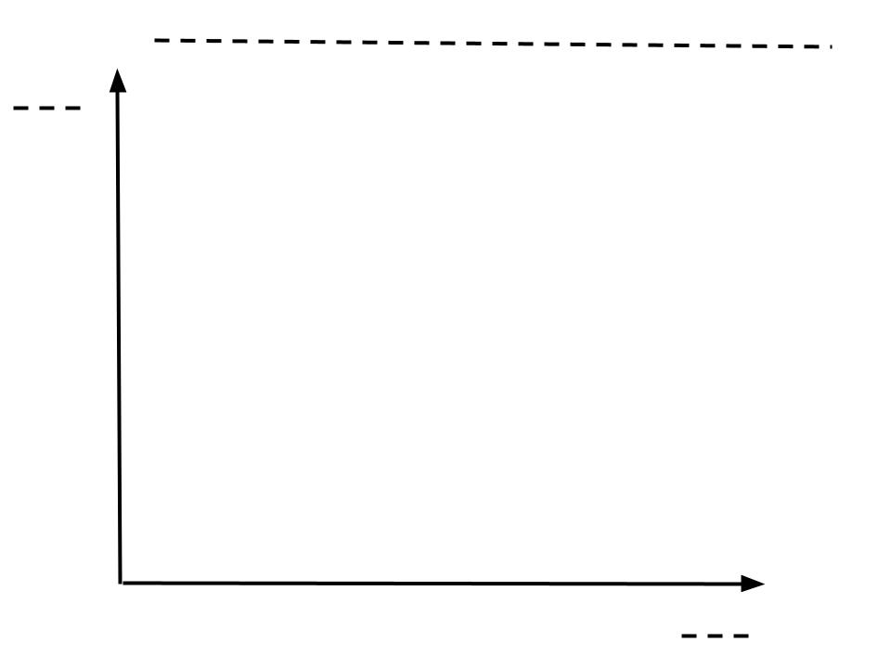

Pęcherzyk poruszał się ruchem........................................................................

Po piętnastu sekundach ruchu pęcherzyk przebył drogę równą ......................

W dwudziestej pierwszej sekundzie ruchu pęcherzyk przebył drogę ...............

**……………….../10 pkt.**

(liczba uzyskanych punktów / maksymalna liczba punktów)

# Zadanie nr 5 (0-1 pkt.)

Zaznacz poprawne dokończenie zdania.

Do wyznaczenia gęstości bryły nieregularnej niezbędne są przyrządy:

▢ waga, miara

▢ cylinder miarowy, waga

▢ cylinder miarowy, miara

▢ waga, siłomierz

**……………….../1 pkt.**

(liczba uzyskanych punktów / maksymalna liczba punktów)

# Zadanie nr 6 (0-5 pkt.)

Pionowo w dół ruchem jednostajnym porusza się spadochroniarz. Jego ciężar wraz ze spadochronem wynosi 800 N. Narysuj i nazwij siły działające na spadochroniarza. Przyjmij, że 200 N to 1 cm.

Siły działające na spadochroniarza:

..............................................................................

..............................................................................

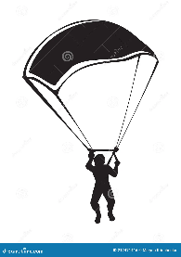

Uzupełnij zdanie.

Powyższą sytuację opisuje ..................... zasada dynamiki Newtona.

**……………….../5 pkt.**

(liczba uzyskanych punktów / maksymalna liczba punktów)

# Zadanie nr 7 (0-7 pkt.)

Oblicz pracę, jaką wykonuje Adam przy podnoszeniu sztangi o masie 120 kg, ruchem jednostajnym na wysokość 1,5 m. Oblicz moc mięśni Adama, który pięć takich podnoszeń wykonał w czasie 1 minuty. Przyjmij, że przyspieszenie ziemskie   
ma wartość g = 10 $\frac{m}{s^{2}}$. Zapisz obliczenia.

|  |  |  |  |  |  |  |  |  |  |  |  |  |  |  |  |  |  |  |  |  |  |  |  |  |  |  |  |  |
| --- | --- | --- | --- | --- | --- | --- | --- | --- | --- | --- | --- | --- | --- | --- | --- | --- | --- | --- | --- | --- | --- | --- | --- | --- | --- | --- | --- | --- |
|  |  |  |  |  |  |  |  |  |  |  |  |  |  |  |  |  |  |  |  |  |  |  |  |  |  |  |  |  |
|  |  |  |  |  |  |  |  |  |  |  |  |  |  |  |  |  |  |  |  |  |  |  |  |  |  |  |  |  |
|  |  |  |  |  |  |  |  |  |  |  |  |  |  |  |  |  |  |  |  |  |  |  |  |  |  |  |  |  |
|  |  |  |  |  |  |  |  |  |  |  |  |  |  |  |  |  |  |  |  |  |  |  |  |  |  |  |  |  |
|  |  |  |  |  |  |  |  |  |  |  |  |  |  |  |  |  |  |  |  |  |  |  |  |  |  |  |  |  |
|  |  |  |  |  |  |  |  |  |  |  |  |  |  |  |  |  |  |  |  |  |  |  |  |  |  |  |  |  |
|  |  |  |  |  |  |  |  |  |  |  |  |  |  |  |  |  |  |  |  |  |  |  |  |  |  |  |  |  |
|  |  |  |  |  |  |  |  |  |  |  |  |  |  |  |  |  |  |  |  |  |  |  |  |  |  |  |  |  |
|  |  |  |  |  |  |  |  |  |  |  |  |  |  |  |  |  |  |  |  |  |  |  |  |  |  |  |  |  |
|  |  |  |  |  |  |  |  |  |  |  |  |  |  |  |  |  |  |  |  |  |  |  |  |  |  |  |  |  |
|  |  |  |  |  |  |  |  |  |  |  |  |  |  |  |  |  |  |  |  |  |  |  |  |  |  |  |  |  |
|  |  |  |  |  |  |  |  |  |  |  |  |  |  |  |  |  |  |  |  |  |  |  |  |  |  |  |  |  |
|  |  |  |  |  |  |  |  |  |  |  |  |  |  |  |  |  |  |  |  |  |  |  |  |  |  |  |  |  |
|  |  |  |  |  |  |  |  |  |  |  |  |  |  |  |  |  |  |  |  |  |  |  |  |  |  |  |  |  |
|  |  |  |  |  |  |  |  |  |  |  |  |  |  |  |  |  |  |  |  |  |  |  |  |  |  |  |  |  |
|  |  |  |  |  |  |  |  |  |  |  |  |  |  |  |  |  |  |  |  |  |  |  |  |  |  |  |  |  |

**……………….../7 pkt.**

(liczba uzyskanych punktów / maksymalna liczba punktów)

# Zadanie nr 8 (0-1 pkt.)

Gęstość aluminium wynosi 2700 $\frac{kg}{m^{3}}$. Przelicz wartość gęstości aluminium na $\frac{dag}{dm^{3}}$.  
Zapisz obliczenia.

|  |  |  |  |  |  |  |  |  |  |  |  |  |  |  |  |  |  |  |  |  |  |  |  |  |  |  |  |  |
| --- | --- | --- | --- | --- | --- | --- | --- | --- | --- | --- | --- | --- | --- | --- | --- | --- | --- | --- | --- | --- | --- | --- | --- | --- | --- | --- | --- | --- |
|  |  |  |  |  |  |  |  |  |  |  |  |  |  |  |  |  |  |  |  |  |  |  |  |  |  |  |  |  |
|  |  |  |  |  |  |  |  |  |  |  |  |  |  |  |  |  |  |  |  |  |  |  |  |  |  |  |  |  |
|  |  |  |  |  |  |  |  |  |  |  |  |  |  |  |  |  |  |  |  |  |  |  |  |  |  |  |  |  |

**……………….../1 pkt.**

(liczba uzyskanych punktów / maksymalna liczba punktów)

# Zadanie nr 9 (0-5 pkt.)

Na ciało o masie 4 kg działają dwie siły F1 = 12 N oraz F2 = 20 N. Oblicz przyspieszenie, z jakim będzie poruszać się to ciało. Rozważ wszystkie przypadki. Zapisz obliczenia.

|  |  |  |  |  |  |  |  |  |  |  |  |  |  |  |  |  |  |  |  |  |  |  |  |  |  |  |  |  |
| --- | --- | --- | --- | --- | --- | --- | --- | --- | --- | --- | --- | --- | --- | --- | --- | --- | --- | --- | --- | --- | --- | --- | --- | --- | --- | --- | --- | --- |
|  |  |  |  |  |  |  |  |  |  |  |  |  |  |  |  |  |  |  |  |  |  |  |  |  |  |  |  |  |
|  |  |  |  |  |  |  |  |  |  |  |  |  |  |  |  |  |  |  |  |  |  |  |  |  |  |  |  |  |
|  |  |  |  |  |  |  |  |  |  |  |  |  |  |  |  |  |  |  |  |  |  |  |  |  |  |  |  |  |
|  |  |  |  |  |  |  |  |  |  |  |  |  |  |  |  |  |  |  |  |  |  |  |  |  |  |  |  |  |
|  |  |  |  |  |  |  |  |  |  |  |  |  |  |  |  |  |  |  |  |  |  |  |  |  |  |  |  |  |
|  |  |  |  |  |  |  |  |  |  |  |  |  |  |  |  |  |  |  |  |  |  |  |  |  |  |  |  |  |
|  |  |  |  |  |  |  |  |  |  |  |  |  |  |  |  |  |  |  |  |  |  |  |  |  |  |  |  |  |
|  |  |  |  |  |  |  |  |  |  |  |  |  |  |  |  |  |  |  |  |  |  |  |  |  |  |  |  |  |
|  |  |  |  |  |  |  |  |  |  |  |  |  |  |  |  |  |  |  |  |  |  |  |  |  |  |  |  |  |
|  |  |  |  |  |  |  |  |  |  |  |  |  |  |  |  |  |  |  |  |  |  |  |  |  |  |  |  |  |

**……………….../5 pkt.**

(liczba uzyskanych punktów / maksymalna liczba punktów)

# Zadanie nr 10 (0-4 pkt.)

Napisz, jak i o ile zmieni się energia kinetyczna ciała o masie 4 kg, które zwiększy swoją szybkość z 7 $\frac{m}{s}$ do 10 $\frac{m}{s}$. Zapisz obliczenia.

|  |  |  |  |  |  |  |  |  |  |  |  |  |  |  |  |  |  |  |  |  |  |  |  |  |  |  |  |  |
| --- | --- | --- | --- | --- | --- | --- | --- | --- | --- | --- | --- | --- | --- | --- | --- | --- | --- | --- | --- | --- | --- | --- | --- | --- | --- | --- | --- | --- |
|  |  |  |  |  |  |  |  |  |  |  |  |  |  |  |  |  |  |  |  |  |  |  |  |  |  |  |  |  |
|  |  |  |  |  |  |  |  |  |  |  |  |  |  |  |  |  |  |  |  |  |  |  |  |  |  |  |  |  |
|  |  |  |  |  |  |  |  |  |  |  |  |  |  |  |  |  |  |  |  |  |  |  |  |  |  |  |  |  |
|  |  |  |  |  |  |  |  |  |  |  |  |  |  |  |  |  |  |  |  |  |  |  |  |  |  |  |  |  |
|  |  |  |  |  |  |  |  |  |  |  |  |  |  |  |  |  |  |  |  |  |  |  |  |  |  |  |  |  |
|  |  |  |  |  |  |  |  |  |  |  |  |  |  |  |  |  |  |  |  |  |  |  |  |  |  |  |  |  |
|  |  |  |  |  |  |  |  |  |  |  |  |  |  |  |  |  |  |  |  |  |  |  |  |  |  |  |  |  |
|  |  |  |  |  |  |  |  |  |  |  |  |  |  |  |  |  |  |  |  |  |  |  |  |  |  |  |  |  |
|  |  |  |  |  |  |  |  |  |  |  |  |  |  |  |  |  |  |  |  |  |  |  |  |  |  |  |  |  |

**……………….../4 pkt.**

(liczba uzyskanych punktów / maksymalna liczba punktów)

# Zadanie nr 11 (0-1 pkt.)

Oblicz masę ciała zawieszonego na siłomierzu, jeżeli siłomierz wskazuje wartość siły ciężkości równą 12 N.

|  |  |  |  |  |  |  |  |  |  |  |  |  |  |  |  |  |  |  |  |  |  |  |  |  |  |  |  |  |
| --- | --- | --- | --- | --- | --- | --- | --- | --- | --- | --- | --- | --- | --- | --- | --- | --- | --- | --- | --- | --- | --- | --- | --- | --- | --- | --- | --- | --- |
|  |  |  |  |  |  |  |  |  |  |  |  |  |  |  |  |  |  |  |  |  |  |  |  |  |  |  |  |  |
|  |  |  |  |  |  |  |  |  |  |  |  |  |  |  |  |  |  |  |  |  |  |  |  |  |  |  |  |  |
|  |  |  |  |  |  |  |  |  |  |  |  |  |  |  |  |  |  |  |  |  |  |  |  |  |  |  |  |  |

**……………….../1 pkt.**

(liczba uzyskanych punktów / maksymalna liczba punktów)

# Zadanie nr 12 (0-5 pkt.)

Piłka do koszykówki o masie 550 g została upuszczona z wysokości 4 m. Napisz,   
jak i o ile zmieni się energia potencjalna piłki, gdy ta będzie na wysokości 1,5 m. Przyjmij, że przyspieszenie ziemskie ma wartość g = 10 $\frac{m}{s^{2}}$. Zapisz obliczenia.

|  |  |  |  |  |  |  |  |  |  |  |  |  |  |  |  |  |  |  |  |  |  |  |  |  |  |  |  |  |
| --- | --- | --- | --- | --- | --- | --- | --- | --- | --- | --- | --- | --- | --- | --- | --- | --- | --- | --- | --- | --- | --- | --- | --- | --- | --- | --- | --- | --- |
|  |  |  |  |  |  |  |  |  |  |  |  |  |  |  |  |  |  |  |  |  |  |  |  |  |  |  |  |  |
|  |  |  |  |  |  |  |  |  |  |  |  |  |  |  |  |  |  |  |  |  |  |  |  |  |  |  |  |  |
|  |  |  |  |  |  |  |  |  |  |  |  |  |  |  |  |  |  |  |  |  |  |  |  |  |  |  |  |  |
|  |  |  |  |  |  |  |  |  |  |  |  |  |  |  |  |  |  |  |  |  |  |  |  |  |  |  |  |  |
|  |  |  |  |  |  |  |  |  |  |  |  |  |  |  |  |  |  |  |  |  |  |  |  |  |  |  |  |  |
|  |  |  |  |  |  |  |  |  |  |  |  |  |  |  |  |  |  |  |  |  |  |  |  |  |  |  |  |  |
|  |  |  |  |  |  |  |  |  |  |  |  |  |  |  |  |  |  |  |  |  |  |  |  |  |  |  |  |  |
|  |  |  |  |  |  |  |  |  |  |  |  |  |  |  |  |  |  |  |  |  |  |  |  |  |  |  |  |  |
|  |  |  |  |  |  |  |  |  |  |  |  |  |  |  |  |  |  |  |  |  |  |  |  |  |  |  |  |  |
|  |  |  |  |  |  |  |  |  |  |  |  |  |  |  |  |  |  |  |  |  |  |  |  |  |  |  |  |  |
|  |  |  |  |  |  |  |  |  |  |  |  |  |  |  |  |  |  |  |  |  |  |  |  |  |  |  |  |  |
|  |  |  |  |  |  |  |  |  |  |  |  |  |  |  |  |  |  |  |  |  |  |  |  |  |  |  |  |  |
|  |  |  |  |  |  |  |  |  |  |  |  |  |  |  |  |  |  |  |  |  |  |  |  |  |  |  |  |  |
|  |  |  |  |  |  |  |  |  |  |  |  |  |  |  |  |  |  |  |  |  |  |  |  |  |  |  |  |  |
|  |  |  |  |  |  |  |  |  |  |  |  |  |  |  |  |  |  |  |  |  |  |  |  |  |  |  |  |  |
|  |  |  |  |  |  |  |  |  |  |  |  |  |  |  |  |  |  |  |  |  |  |  |  |  |  |  |  |  |
|  |  |  |  |  |  |  |  |  |  |  |  |  |  |  |  |  |  |  |  |  |  |  |  |  |  |  |  |  |

**……………….../5 pkt.**

(liczba uzyskanych punktów / maksymalna liczba punktów)

# Zadanie nr 13 (0-5 pkt.)

Na rysunku przedstawiono dźwignię dwustronną, która nie znajduje się w stanie równowagi. Na końcach dźwigni ustawiono ciała o różnych masach. Napisz,   
na którym ciele należy położyć jeden, dodatkowy odważnik i o jakiej masie,   
aby zrównoważyć dźwignię. Dźwignia ma długość 2 m. Zapisz obliczenia.

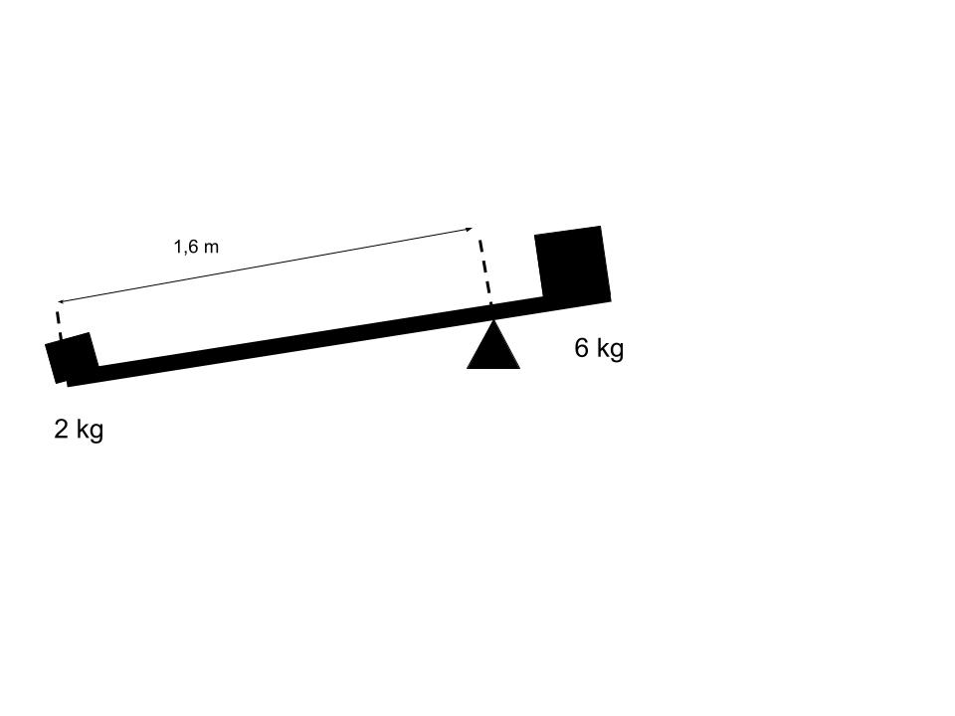

|  |  |  |  |  |  |  |  |  |  |  |  |  |  |  |  |  |  |  |  |  |  |  |  |  |  |  |  |  |
| --- | --- | --- | --- | --- | --- | --- | --- | --- | --- | --- | --- | --- | --- | --- | --- | --- | --- | --- | --- | --- | --- | --- | --- | --- | --- | --- | --- | --- |
|  |  |  |  |  |  |  |  |  |  |  |  |  |  |  |  |  |  |  |  |  |  |  |  |  |  |  |  |  |
|  |  |  |  |  |  |  |  |  |  |  |  |  |  |  |  |  |  |  |  |  |  |  |  |  |  |  |  |  |
|  |  |  |  |  |  |  |  |  |  |  |  |  |  |  |  |  |  |  |  |  |  |  |  |  |  |  |  |  |
|  |  |  |  |  |  |  |  |  |  |  |  |  |  |  |  |  |  |  |  |  |  |  |  |  |  |  |  |  |
|  |  |  |  |  |  |  |  |  |  |  |  |  |  |  |  |  |  |  |  |  |  |  |  |  |  |  |  |  |
|  |  |  |  |  |  |  |  |  |  |  |  |  |  |  |  |  |  |  |  |  |  |  |  |  |  |  |  |  |
|  |  |  |  |  |  |  |  |  |  |  |  |  |  |  |  |  |  |  |  |  |  |  |  |  |  |  |  |  |
|  |  |  |  |  |  |  |  |  |  |  |  |  |  |  |  |  |  |  |  |  |  |  |  |  |  |  |  |  |
|  |  |  |  |  |  |  |  |  |  |  |  |  |  |  |  |  |  |  |  |  |  |  |  |  |  |  |  |  |
|  |  |  |  |  |  |  |  |  |  |  |  |  |  |  |  |  |  |  |  |  |  |  |  |  |  |  |  |  |

**……………….../5 pkt.**

(liczba uzyskanych punktów / maksymalna liczba punktów)

# Zadanie nr 14 (0-6 pkt.)

Oblicz ciśnienie na dnie Rowu Marjańskiego o głębokości około 11 km. Przyjmij,   
że gęstość wody wynosi 1000 $\frac{kg}{m^{3}}$, przyspieszenie ziemskie ma wartość g = 10 $\frac{m}{s^{2}}$  
i ciśnienie atmosferyczne wynosi 1013 hPa. Zapisz obliczenia.

|  |  |  |  |  |  |  |  |  |  |  |  |  |  |  |  |  |  |  |  |  |  |  |  |  |  |  |  |  |
| --- | --- | --- | --- | --- | --- | --- | --- | --- | --- | --- | --- | --- | --- | --- | --- | --- | --- | --- | --- | --- | --- | --- | --- | --- | --- | --- | --- | --- |
|  |  |  |  |  |  |  |  |  |  |  |  |  |  |  |  |  |  |  |  |  |  |  |  |  |  |  |  |  |
|  |  |  |  |  |  |  |  |  |  |  |  |  |  |  |  |  |  |  |  |  |  |  |  |  |  |  |  |  |
|  |  |  |  |  |  |  |  |  |  |  |  |  |  |  |  |  |  |  |  |  |  |  |  |  |  |  |  |  |
|  |  |  |  |  |  |  |  |  |  |  |  |  |  |  |  |  |  |  |  |  |  |  |  |  |  |  |  |  |
|  |  |  |  |  |  |  |  |  |  |  |  |  |  |  |  |  |  |  |  |  |  |  |  |  |  |  |  |  |
|  |  |  |  |  |  |  |  |  |  |  |  |  |  |  |  |  |  |  |  |  |  |  |  |  |  |  |  |  |
|  |  |  |  |  |  |  |  |  |  |  |  |  |  |  |  |  |  |  |  |  |  |  |  |  |  |  |  |  |
|  |  |  |  |  |  |  |  |  |  |  |  |  |  |  |  |  |  |  |  |  |  |  |  |  |  |  |  |  |
|  |  |  |  |  |  |  |  |  |  |  |  |  |  |  |  |  |  |  |  |  |  |  |  |  |  |  |  |  |

**……………….../6 pkt.**

(liczba uzyskanych punktów / maksymalna liczba punktów)

# Zadanie nr 15 (0-6 pkt.)

Oblicz objętość ciała zanurzonego w oliwie o gęstości 0,92 $\frac{g}{{cm}^{3}}$, jeżeli wartość siły wyporu, jaka działa na to ciało wynosi 3 kN. Przyjmij, że przyspieszenie ziemskie   
ma wartość g = 10 $\frac{m}{s^{2}}$. Wynik zapisz z dokładnością do części setnych metra sześciennego. Zapisz obliczenia.

|  |  |  |  |  |  |  |  |  |  |  |  |  |  |  |  |  |  |  |  |  |  |  |  |  |  |  |  |  |
| --- | --- | --- | --- | --- | --- | --- | --- | --- | --- | --- | --- | --- | --- | --- | --- | --- | --- | --- | --- | --- | --- | --- | --- | --- | --- | --- | --- | --- |
|  |  |  |  |  |  |  |  |  |  |  |  |  |  |  |  |  |  |  |  |  |  |  |  |  |  |  |  |  |
|  |  |  |  |  |  |  |  |  |  |  |  |  |  |  |  |  |  |  |  |  |  |  |  |  |  |  |  |  |
|  |  |  |  |  |  |  |  |  |  |  |  |  |  |  |  |  |  |  |  |  |  |  |  |  |  |  |  |  |
|  |  |  |  |  |  |  |  |  |  |  |  |  |  |  |  |  |  |  |  |  |  |  |  |  |  |  |  |  |
|  |  |  |  |  |  |  |  |  |  |  |  |  |  |  |  |  |  |  |  |  |  |  |  |  |  |  |  |  |
|  |  |  |  |  |  |  |  |  |  |  |  |  |  |  |  |  |  |  |  |  |  |  |  |  |  |  |  |  |
|  |  |  |  |  |  |  |  |  |  |  |  |  |  |  |  |  |  |  |  |  |  |  |  |  |  |  |  |  |
|  |  |  |  |  |  |  |  |  |  |  |  |  |  |  |  |  |  |  |  |  |  |  |  |  |  |  |  |  |
|  |  |  |  |  |  |  |  |  |  |  |  |  |  |  |  |  |  |  |  |  |  |  |  |  |  |  |  |  |
|  |  |  |  |  |  |  |  |  |  |  |  |  |  |  |  |  |  |  |  |  |  |  |  |  |  |  |  |  |
|  |  |  |  |  |  |  |  |  |  |  |  |  |  |  |  |  |  |  |  |  |  |  |  |  |  |  |  |  |
|  |  |  |  |  |  |  |  |  |  |  |  |  |  |  |  |  |  |  |  |  |  |  |  |  |  |  |  |  |
|  |  |  |  |  |  |  |  |  |  |  |  |  |  |  |  |  |  |  |  |  |  |  |  |  |  |  |  |  |
|  |  |  |  |  |  |  |  |  |  |  |  |  |  |  |  |  |  |  |  |  |  |  |  |  |  |  |  |  |

**……………….../6 pkt.**

(liczba uzyskanych punktów / maksymalna liczba punktów)

# Zadanie nr 16 (0-5 pkt.)

Oblicz pęd pojazdu o masie 2,5 tony, poruszającego się ze stałą szybkością 72 $\frac{km}{h}$.

Zapisz obliczenia.

|  |  |  |  |  |  |  |  |  |  |  |  |  |  |  |  |  |  |  |  |  |  |  |  |  |  |  |  |  |
| --- | --- | --- | --- | --- | --- | --- | --- | --- | --- | --- | --- | --- | --- | --- | --- | --- | --- | --- | --- | --- | --- | --- | --- | --- | --- | --- | --- | --- |
|  |  |  |  |  |  |  |  |  |  |  |  |  |  |  |  |  |  |  |  |  |  |  |  |  |  |  |  |  |
|  |  |  |  |  |  |  |  |  |  |  |  |  |  |  |  |  |  |  |  |  |  |  |  |  |  |  |  |  |
|  |  |  |  |  |  |  |  |  |  |  |  |  |  |  |  |  |  |  |  |  |  |  |  |  |  |  |  |  |
|  |  |  |  |  |  |  |  |  |  |  |  |  |  |  |  |  |  |  |  |  |  |  |  |  |  |  |  |  |
|  |  |  |  |  |  |  |  |  |  |  |  |  |  |  |  |  |  |  |  |  |  |  |  |  |  |  |  |  |
|  |  |  |  |  |  |  |  |  |  |  |  |  |  |  |  |  |  |  |  |  |  |  |  |  |  |  |  |  |
|  |  |  |  |  |  |  |  |  |  |  |  |  |  |  |  |  |  |  |  |  |  |  |  |  |  |  |  |  |
|  |  |  |  |  |  |  |  |  |  |  |  |  |  |  |  |  |  |  |  |  |  |  |  |  |  |  |  |  |
|  |  |  |  |  |  |  |  |  |  |  |  |  |  |  |  |  |  |  |  |  |  |  |  |  |  |  |  |  |

**……………….../5 pkt.**  
 (liczba uzyskanych punktów / maksymalna liczba punktów)

# Zadanie nr 17 (0-4 pkt.)

Na podstawie wykresu zależności szybkości od czasu dla ruchu pewnego ciała dokończ poniższe zdania. Zapisz obliczenia.

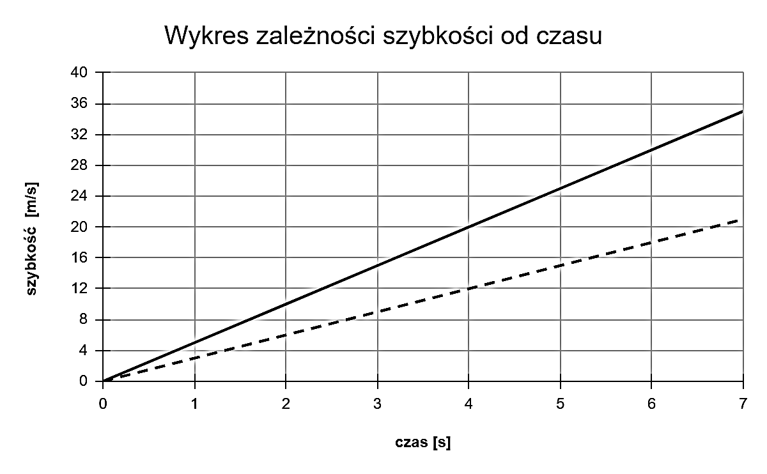

Zmiana szybkości od 0 s do 4 s dla linii przerywanej wynosi: .......................

Wartość przyspieszenia dla linii przerywanej wynosi: ......................................

Wartość przyspieszenia dla linii ciągłej wynosi: ................................

Iloraz najmniejszego przyspieszenia do największego wynosi: ..................................

|  |  |  |  |  |  |  |  |  |  |  |  |  |  |  |  |  |  |  |  |  |  |  |  |  |  |  |  |  |
| --- | --- | --- | --- | --- | --- | --- | --- | --- | --- | --- | --- | --- | --- | --- | --- | --- | --- | --- | --- | --- | --- | --- | --- | --- | --- | --- | --- | --- |
|  |  |  |  |  |  |  |  |  |  |  |  |  |  |  |  |  |  |  |  |  |  |  |  |  |  |  |  |  |
|  |  |  |  |  |  |  |  |  |  |  |  |  |  |  |  |  |  |  |  |  |  |  |  |  |  |  |  |  |
|  |  |  |  |  |  |  |  |  |  |  |  |  |  |  |  |  |  |  |  |  |  |  |  |  |  |  |  |  |
|  |  |  |  |  |  |  |  |  |  |  |  |  |  |  |  |  |  |  |  |  |  |  |  |  |  |  |  |  |
|  |  |  |  |  |  |  |  |  |  |  |  |  |  |  |  |  |  |  |  |  |  |  |  |  |  |  |  |  |

**……………….../4 pkt.**  
 (liczba uzyskanych punktów / maksymalna liczba punktów)

# Zadanie nr 18 (0-4 pkt.)

W prasie hydraulicznej na mały tłok o powierzchni 2 cm2 działa siła o wartości 200 N. Oblicz siłę, jaka podnosi duży tłok o powierzchni 0,004 m2. Zapisz obliczenia.

|  |  |  |  |  |  |  |  |  |  |  |  |  |  |  |  |  |  |  |  |  |  |  |  |  |  |  |  |  |
| --- | --- | --- | --- | --- | --- | --- | --- | --- | --- | --- | --- | --- | --- | --- | --- | --- | --- | --- | --- | --- | --- | --- | --- | --- | --- | --- | --- | --- |
|  |  |  |  |  |  |  |  |  |  |  |  |  |  |  |  |  |  |  |  |  |  |  |  |  |  |  |  |  |
|  |  |  |  |  |  |  |  |  |  |  |  |  |  |  |  |  |  |  |  |  |  |  |  |  |  |  |  |  |
|  |  |  |  |  |  |  |  |  |  |  |  |  |  |  |  |  |  |  |  |  |  |  |  |  |  |  |  |  |
|  |  |  |  |  |  |  |  |  |  |  |  |  |  |  |  |  |  |  |  |  |  |  |  |  |  |  |  |  |
|  |  |  |  |  |  |  |  |  |  |  |  |  |  |  |  |  |  |  |  |  |  |  |  |  |  |  |  |  |
|  |  |  |  |  |  |  |  |  |  |  |  |  |  |  |  |  |  |  |  |  |  |  |  |  |  |  |  |  |

**……………….../4 pkt.**  
 (liczba uzyskanych punktów / maksymalna liczba punktów)

# Zadanie nr 19 (0-6 pkt.)

Oblicz, jaką masę ma metalowa szafa w kształcie prostopadłościanu o wymiarach 200 cm x 120 cm x 60 cm, jeżeli stojąc na najmniejszej ścianie, na poziomej podłodze, wywiera na nią ciśnienie 10 kPa. Zapisz obliczenia.

|  |  |  |  |  |  |  |  |  |  |  |  |  |  |  |  |  |  |  |  |  |  |  |  |  |  |  |  |  |
| --- | --- | --- | --- | --- | --- | --- | --- | --- | --- | --- | --- | --- | --- | --- | --- | --- | --- | --- | --- | --- | --- | --- | --- | --- | --- | --- | --- | --- |
|  |  |  |  |  |  |  |  |  |  |  |  |  |  |  |  |  |  |  |  |  |  |  |  |  |  |  |  |  |
|  |  |  |  |  |  |  |  |  |  |  |  |  |  |  |  |  |  |  |  |  |  |  |  |  |  |  |  |  |
|  |  |  |  |  |  |  |  |  |  |  |  |  |  |  |  |  |  |  |  |  |  |  |  |  |  |  |  |  |
|  |  |  |  |  |  |  |  |  |  |  |  |  |  |  |  |  |  |  |  |  |  |  |  |  |  |  |  |  |
|  |  |  |  |  |  |  |  |  |  |  |  |  |  |  |  |  |  |  |  |  |  |  |  |  |  |  |  |  |
|  |  |  |  |  |  |  |  |  |  |  |  |  |  |  |  |  |  |  |  |  |  |  |  |  |  |  |  |  |
|  |  |  |  |  |  |  |  |  |  |  |  |  |  |  |  |  |  |  |  |  |  |  |  |  |  |  |  |  |
|  |  |  |  |  |  |  |  |  |  |  |  |  |  |  |  |  |  |  |  |  |  |  |  |  |  |  |  |  |
|  |  |  |  |  |  |  |  |  |  |  |  |  |  |  |  |  |  |  |  |  |  |  |  |  |  |  |  |  |

**……………….../6 pkt.**  
 (liczba uzyskanych punktów / maksymalna liczba punktów)

# Zadanie nr 20 (0-5 pkt.)

Pociąg w wyniku działania siły ciągu silnika o wartości 300 N, porusza się ruchem jednostajnym z szybkością 20 $\frac{m}{s}$. Oblicz moc tego silnika. Zapisz obliczenia.

|  |  |  |  |  |  |  |  |  |  |  |  |  |  |  |  |  |  |  |  |  |  |  |  |  |  |  |  |  |
| --- | --- | --- | --- | --- | --- | --- | --- | --- | --- | --- | --- | --- | --- | --- | --- | --- | --- | --- | --- | --- | --- | --- | --- | --- | --- | --- | --- | --- |
|  |  |  |  |  |  |  |  |  |  |  |  |  |  |  |  |  |  |  |  |  |  |  |  |  |  |  |  |  |
|  |  |  |  |  |  |  |  |  |  |  |  |  |  |  |  |  |  |  |  |  |  |  |  |  |  |  |  |  |
|  |  |  |  |  |  |  |  |  |  |  |  |  |  |  |  |  |  |  |  |  |  |  |  |  |  |  |  |  |
|  |  |  |  |  |  |  |  |  |  |  |  |  |  |  |  |  |  |  |  |  |  |  |  |  |  |  |  |  |
|  |  |  |  |  |  |  |  |  |  |  |  |  |  |  |  |  |  |  |  |  |  |  |  |  |  |  |  |  |
|  |  |  |  |  |  |  |  |  |  |  |  |  |  |  |  |  |  |  |  |  |  |  |  |  |  |  |  |  |
|  |  |  |  |  |  |  |  |  |  |  |  |  |  |  |  |  |  |  |  |  |  |  |  |  |  |  |  |  |

**……………….../5 pkt.**  
 (liczba uzyskanych punktów / maksymalna liczba punktów)

# Zadanie nr 21 (0-4 pkt.)

Zaznacz poprawność P lub fałszywość F zdań. P F

1. Jednostką energii kinetycznej jest Pa. ▢ ▢
2. Jednostką wartości siły jest N. ▢ ▢
3. I zasada dynamiki Newtona opisuje oddziaływanie  
   między Ziemią, a Księżycem. ▢ ▢
4. W celu obliczenia objętości ciała należy jego  
   masę podzielić przez gęstość. ▢ ▢

**……………….../4 pkt.**  
 (liczba uzyskanych punktów / maksymalna liczba punktów)

**Brudnopis**

|  |  |  |  |  |  |  |  |  |  |  |  |  |  |  |  |  |  |  |  |  |  |  |  |  |  |  |  |  |
| --- | --- | --- | --- | --- | --- | --- | --- | --- | --- | --- | --- | --- | --- | --- | --- | --- | --- | --- | --- | --- | --- | --- | --- | --- | --- | --- | --- | --- |
|  |  |  |  |  |  |  |  |  |  |  |  |  |  |  |  |  |  |  |  |  |  |  |  |  |  |  |  |  |
|  |  |  |  |  |  |  |  |  |  |  |  |  |  |  |  |  |  |  |  |  |  |  |  |  |  |  |  |  |
|  |  |  |  |  |  |  |  |  |  |  |  |  |  |  |  |  |  |  |  |  |  |  |  |  |  |  |  |  |
|  |  |  |  |  |  |  |  |  |  |  |  |  |  |  |  |  |  |  |  |  |  |  |  |  |  |  |  |  |
|  |  |  |  |  |  |  |  |  |  |  |  |  |  |  |  |  |  |  |  |  |  |  |  |  |  |  |  |  |
|  |  |  |  |  |  |  |  |  |  |  |  |  |  |  |  |  |  |  |  |  |  |  |  |  |  |  |  |  |
|  |  |  |  |  |  |  |  |  |  |  |  |  |  |  |  |  |  |  |  |  |  |  |  |  |  |  |  |  |
|  |  |  |  |  |  |  |  |  |  |  |  |  |  |  |  |  |  |  |  |  |  |  |  |  |  |  |  |  |
|  |  |  |  |  |  |  |  |  |  |  |  |  |  |  |  |  |  |  |  |  |  |  |  |  |  |  |  |  |
|  |  |  |  |  |  |  |  |  |  |  |  |  |  |  |  |  |  |  |  |  |  |  |  |  |  |  |  |  |
|  |  |  |  |  |  |  |  |  |  |  |  |  |  |  |  |  |  |  |  |  |  |  |  |  |  |  |  |  |
|  |  |  |  |  |  |  |  |  |  |  |  |  |  |  |  |  |  |  |  |  |  |  |  |  |  |  |  |  |
|  |  |  |  |  |  |  |  |  |  |  |  |  |  |  |  |  |  |  |  |  |  |  |  |  |  |  |  |  |
|  |  |  |  |  |  |  |  |  |  |  |  |  |  |  |  |  |  |  |  |  |  |  |  |  |  |  |  |  |
|  |  |  |  |  |  |  |  |  |  |  |  |  |  |  |  |  |  |  |  |  |  |  |  |  |  |  |  |  |
|  |  |  |  |  |  |  |  |  |  |  |  |  |  |  |  |  |  |  |  |  |  |  |  |  |  |  |  |  |
|  |  |  |  |  |  |  |  |  |  |  |  |  |  |  |  |  |  |  |  |  |  |  |  |  |  |  |  |  |
|  |  |  |  |  |  |  |  |  |  |  |  |  |  |  |  |  |  |  |  |  |  |  |  |  |  |  |  |  |
|  |  |  |  |  |  |  |  |  |  |  |  |  |  |  |  |  |  |  |  |  |  |  |  |  |  |  |  |  |
|  |  |  |  |  |  |  |  |  |  |  |  |  |  |  |  |  |  |  |  |  |  |  |  |  |  |  |  |  |
|  |  |  |  |  |  |  |  |  |  |  |  |  |  |  |  |  |  |  |  |  |  |  |  |  |  |  |  |  |
|  |  |  |  |  |  |  |  |  |  |  |  |  |  |  |  |  |  |  |  |  |  |  |  |  |  |  |  |  |
|  |  |  |  |  |  |  |  |  |  |  |  |  |  |  |  |  |  |  |  |  |  |  |  |  |  |  |  |  |
|  |  |  |  |  |  |  |  |  |  |  |  |  |  |  |  |  |  |  |  |  |  |  |  |  |  |  |  |  |
|  |  |  |  |  |  |  |  |  |  |  |  |  |  |  |  |  |  |  |  |  |  |  |  |  |  |  |  |  |
|  |  |  |  |  |  |  |  |  |  |  |  |  |  |  |  |  |  |  |  |  |  |  |  |  |  |  |  |  |
|  |  |  |  |  |  |  |  |  |  |  |  |  |  |  |  |  |  |  |  |  |  |  |  |  |  |  |  |  |
|  |  |  |  |  |  |  |  |  |  |  |  |  |  |  |  |  |  |  |  |  |  |  |  |  |  |  |  |  |
|  |  |  |  |  |  |  |  |  |  |  |  |  |  |  |  |  |  |  |  |  |  |  |  |  |  |  |  |  |
|  |  |  |  |  |  |  |  |  |  |  |  |  |  |  |  |  |  |  |  |  |  |  |  |  |  |  |  |  |
|  |  |  |  |  |  |  |  |  |  |  |  |  |  |  |  |  |  |  |  |  |  |  |  |  |  |  |  |  |
|  |  |  |  |  |  |  |  |  |  |  |  |  |  |  |  |  |  |  |  |  |  |  |  |  |  |  |  |  |
|  |  |  |  |  |  |  |  |  |  |  |  |  |  |  |  |  |  |  |  |  |  |  |  |  |  |  |  |  |
|  |  |  |  |  |  |  |  |  |  |  |  |  |  |  |  |  |  |  |  |  |  |  |  |  |  |  |  |  |
|  |  |  |  |  |  |  |  |  |  |  |  |  |  |  |  |  |  |  |  |  |  |  |  |  |  |  |  |  |
|  |  |  |  |  |  |  |  |  |  |  |  |  |  |  |  |  |  |  |  |  |  |  |  |  |  |  |  |  |